Smart Contracts Research

Resources;

– [medium.com/blockchain-academy-mexico/proyectos-defi-la-evolución-del-movimiento-fintech-86f1347bf1e9](https://medium.com/blockchain-academy-mexico/proyectos-defi-la-evoluci%C3%B3n-del-movimiento-fintech-86f1347bf1e9)

**–** [**polkadot.network/build/**](https://polkadot.network/build/)

– Easily build a Polkadot parachain with Substrate

– Build your application-specific blockchain with the [Substrate](https://www.substrate.io/) framework now and easily connect it to Polkadot after launch.

**–** [**avalabs.org/why-avalanche**](https://www.avalabs.org/why-avalanche)

– Developers who build on Avalanche can easily create powerful, reliable, and secure applications and custom blockchain networks with complex rulesets or build on existing private or public subnets.

**–** [**nexo.io**](https://nexo.io/)

– Earn interest 10%

– Borrow 5.9 APR

– EU licensed & regulated financial institution

**–** [**compound.finance/markets**](https://compound.finance/markets)

– Compound is an algorithmic, autonomous interest rate protocol built for developers, to unlock a universe of open financial applications.

– [PROTOCOL DOCS](https://compound.finance/docs)

– [Discord](https://discord.gg/874ntdw)

**–** [**aave.com**](http://aave.com) **- THE MONEY MARKET PROTOCOL**

– Aave is an open source and non-custodial protocol enabling the creation of money markets. Users can earn interest on deposits and borrow assets.

– [app.aave.com/borrow](https://app.aave.com/borrow)

– **Finanzas Descentralizada Legal, Contable y de Negocio**

– [YouTube video (NoJNDNeaZ-U)](https://www.youtube.com/watch?v=NoJNDNeaZ-U&ab_channel=CONACOM) Finanzas Descentralizada Legal, Contable y de Negocio

– [youtu.be/_bA0p7bxNDo](https://youtu.be/_bA0p7bxNDo)  [Crypto.com](http://crypto.com) ¿Qué es? Tarjetas de debito, exchange, cuentas de ahorro, prestamos, tarjetas de regalo

– [https://www.youtube.com/watch?v=puHKzncMAhk&ab_channel=MADCRIPTOMX](https://youtu.be/_bA0p7bxNDo)- Tokens NO FUNGIBLES: Coleccionables en la blockchain de ETH (NFT) - ERC-721

– [**kleros.io**](http://kleros.io) **- An open online dispute resolution platform bringing justice for all.**

– Peer-to-Peer

– Blockchain and game theory bring fast, affordable and fair decisions.

– Kleros works in a wide variety of industries.

– [crypto.com/en/research/index.html?category=defi](https://crypto.com/en/research/index.html?category=defi)

– [ethereum.org/en/](https://ethereum.org/en/)

– [executive-education-online.mit.edu/presentations/lp/mit-blockchain-technologies-online-short-course/?ef_id=c:347…5895&gclsrc=aw.ds](http://executive-education-online.mit.edu/presentations/lp/mit-blockchain-technologies-online-short-course/?ef_id=c:347%E2%80%A65895&gclsrc=aw.ds) -BLOCKCHAIN TECHNOLOGIES: BUSINESS INNOVATION AND APPLICATION

– **[4/27] Build Blockchain from Scratch | Genesis Block -** [**YouTube video (n6d9iPTx8DM)**](https://www.youtube.com/watch?v=n6d9iPTx8DM&ab_channel=DavidJosephK)

– [medium.com/@tecracoin/what-is-genesis-block-and-why-genesis-block-is-needed-1b37d4b75e43](https://medium.com/@tecracoin/what-is-genesis-block-and-why-genesis-block-is-needed-1b37d4b75e43)

– What is Genesis Block and why Genesis Block is needed?

– The genesis block is the first block in any blockchain-based protocol. It is the basis on which additional blocks are added to form a chain of blocks, hence the term blockchain.

–

– This block is sometimes referred to Block 0. Every block in a blockchain stores a reference to the previous block. In the case of Genesis Block, there is no previous block for reference.

– [morioh.com/p/576ec0f0e1c7](https://morioh.com/p/576ec0f0e1c7)

– How to create a Genesis Block for a new Blockchain with Node.js

– WHAT IS ETHEREUM?

– [ethereum.org/en/what-is-ethereum/](https://ethereum.org/en/what-is-ethereum/)

– Ethereum is open access to digital money and data-friendly services for everyone – no matter your background or location. It's a community-built technology behind the cryptocurrency Ether (ETH) and thousands of applications you can use today.

– Banking for everyone: Not everyone has access to financial services. But all you need to access Ethereum and its lending, borrowing and savings products is an internet connection.

– A more private internet: You don't need to provide all your personal details to use an Ethereum app. Ethereum is building an economy based on value, not surveillance.

– A peer-to-peer network: Ethereum allows you to move money, or make agreements, directly with someone else. You don't need to go through intermediary companies.

– Censorship-resistant: No government or company has control over Ethereum. This decentralization makes it nearly impossible for anyone to stop you from receiving payments or using services on Ethereum.

– Commerce guarantees: Ethereum creates a more level playing field. Customers have a secure, built-in guarantee that funds will only change hands if you provide what was agreed. You don’t need a large company clout to do business.

– Compatibility for the win: Better products and experiences are being built all the time because Ethereum products are compatible by default. Companies can build on each other's success.

– Ethereum - Smart Contracts

– [ethereum.org/en/learn/#smart-contracts](https://ethereum.org/en/learn/#smart-contracts)

– A “smart contract” is simply a piece of code that is running on Ethereum. It’s called a “contract” because code that runs on Ethereum can control valuable things like ETH or other digital assets.

– Getting started - How to buy

– [support.mycrypto.com/how-to/getting-started/how-to-buy-ether-with-usd](https://support.mycrypto.com/how-to/getting-started/how-to-buy-ether-with-usd)

– Ether, or ETH, is Ethereum's native currency. It is "digital money" that can be sent over the internet instantly and cheaply, and also be used in many Ethereum-based applications. (from [ethereum.org](http://ethereum.org))

– You can go to [buy.mycrypto.com](http://buy.mycrypto.com) to buy ETH, BTC, or other cryptocurrencies with US Dollars or Euros (as well as some other currencies).

– You can buy ETH from cryptocurrency exchanges like [Coinbase](https://coinbase-consumer.sjv.io/RVmkN). When you purchase through an exchange, you have an account with that company, and they hold your ETH and your keys for you. Exchanges offer a more traditional username / password scenario where you can do things like reset/change your password and turn on 2FA. They have their own account on the blockchain with all their funds and customer funds. Exchanges store all of your information on their servers, and they keep track of how much ETH they "owe" you.

– [buy.mycrypto.com](https://buy.mycrypto.com/)

– Hardware wallets are the most secure and well worth the investment. If you're just getting started, start with a small amount of funds to get the feel, regardless of the wallet you choose.

– [metamask.io](https://metamask.io/)

– A crypto wallet & gateway to blockchain apps

– Buy, store and send tokens globally: Available as a browser extension and as a mobile app, MetaMask equips you with a key vault, secure login, and token wallet—everything you need to manage your digital assets.

– Explore blockchain apps: MetaMask provides the simplest yet most secure way to connect to blockchain-based applications. You are always in control when interacting on the new decentralized web.

– Own your data: MetaMask generates passwords and keys on your device, so only you have access to your accounts and data. You always choose what to share and what to keep private.

– [youtu.be/YVgfHZMFFFQ](https://youtu.be/YVgfHZMFFFQ)

– 90+ Ethereum Apps You Can Use Right Now

– [consensys.net/blog/news/90-ethereum-apps-you-can-use-right-now/](https://consensys.net/blog/news/90-ethereum-apps-you-can-use-right-now/)

– Blockchain Domain Names

– [unstoppabledomains.com](https://unstoppabledomains.com/)

– Create your own Ethereum ERC20-Token

– [axom-software.com/en/blog/2019/07/blockchain/1562846735/create-your-own-ethereum-erc20-token](https://axom-software.com/en/blog/2019/07/blockchain/1562846735/create-your-own-ethereum-erc20-token)

– Ethereum ERC20-Token, which could be used for an ITO (Initial Token Offering) and could be traded on the Ethereum Blockchain.

– A blockchain is an audit-proof digital general ledger of transactions which can record not only financial transactions, but virtually any type of transaction.

–

– Ethereum Studio

– [studio.ethereum.org/5f519dc126b47300123674b7?openFile=README.md](https://studio.ethereum.org/5f519dc126b47300123674b7?openFile=README.md)

– Web3.js

– [web3js.readthedocs.io/en/v1.2.0/getting-started.html](https://web3js.readthedocs.io/en/v1.2.0/getting-started.html)

– The web3.js library is a collection of modules which contain specific functionality for the ethereum ecosystem.

– The **web3-eth** is for the **ethereum blockchain** and **smart contracts**

– The **web3-shh** is for the **whisper** protocol to communicate p2p and broadcast

– The **web3-bzz** is for the **swarm** protocol, the decentralized file storage

– The **web3-utils** contains useful helper functions for **Dapp** **developers**.

– OpenZeppelin : Tokens

– [docs.openzeppelin.com/contracts/3.x/](https://docs.openzeppelin.com/contracts/3.x/)

– Ah, the "token": blockchain’s most powerful and most misunderstood tool.

– A token is a representation of something in the blockchain. This something can be money, time, services, shares in a company, a virtual pet, anything. By representing things as tokens, we can allow smart contracts to interact with them, exchange them, create or destroy them.

– A token contract is simply an Ethereum smart contract. "Sending tokens" actually means "calling a method on a smart contract that someone wrote and deployed". At the end of the day, a token contract is not much more a mapping of addresses to balances, plus some methods to add and subtract from those balances.

– A token contract is simply an Ethereum smart contract. "Sending tokens" actually means "calling a method on a smart contract that someone wrote and deployed". At the end of the day, a token contract is not much more a mapping of addresses to balances, plus some methods to add and subtract from those balances.

– [ERC20](https://docs.openzeppelin.com/contracts/2.x/erc20): the most widespread token standard for fungible assets, albeit somewhat limited by its simplicity.

– [ERC721](https://docs.openzeppelin.com/contracts/2.x/erc721): the de-facto solution for non-fungible tokens, often used for collectibles and games.

– [ERC777](https://docs.openzeppelin.com/contracts/2.x/erc777): a richer standard for fungible tokens, enabling new use cases and building on past learnings. Backwards compatible with ERC20.

– **ERC20:** [**docs.openzeppelin.com/contracts/2.x/erc20**](https://docs.openzeppelin.com/contracts/2.x/erc20)

– An ERC20 token contract keeps track of [fungible tokens](https://docs.openzeppelin.com/contracts/2.x/tokens#different-kinds-of-tokens): any one token is exactly equal to any other token; no tokens have special rights or behavior associated with them. This makes ERC20 tokens useful for things like a medium of exchange currency, voting rights, staking, and more.

– [Ethereum Improvement Proposals](https://eips.ethereum.org/)

**– Get started building on Ethereum**

– [ethereum.org/en/build/](https://ethereum.org/en/build/)

– Learn the basics of Ethereum with Ethereum Studio, our web-based IDE where you can create and test smart contracts, and build a frontend for them.

– Start coding right away, saving time with development setup. Try the following templates to see what you can build with Ethereum.

– **Ether.js** ibrary aims to be a complete and compact library for interacting with the Ethereum Blockchain and its ecosystem. It was originally designed for use with [ethers.io](http://ethers.io) and has since expanded into a much more general-purpose library.

– [docs.ethers.io/v5/](https://docs.ethers.io/v5/)

– [etherscan.io](http://etherscan.io) - The Ethereum Blockchain Explorer

– **Dapp**

– [dapp.tools/dapp/](https://dapp.tools/dapp/)

– The dapp command is the basic user-facing tool in our development toolkit.

– It is opinionated and designed to support a simple and robust workflow while being fast, predictable, and a good citizen of the Unix command line.

– You can get started with dapp development very easily

– **Introduction to Smart Contracts**

– [solidity.readthedocs.io/en/latest/introduction-to-smart-contracts.html](https://solidity.readthedocs.io/en/latest/introduction-to-smart-contracts.html)

– A contract in the sense of Solidity is a collection of code (its functions) and data (its state) that resides at a specific address on the Ethereum blockchain. The line uint storedData; declares a state variable called storedData of type uint (unsigned integer of 256 bits). You can think of it as a single slot in a database that you can query and alter by calling functions of the code that manages the database. In this example, the contract defines the functions set and get that can be used to modify or retrieve the value of the variable.

– **Security Considerations**

– [solidity.readthedocs.io/en/latest/security-considerations.html](https://solidity.readthedocs.io/en/latest/security-considerations.html)

– Everything you use in a smart contract is publicly visible, even local variables and state variables marked private.

– **List of Known Bugs**

– [solidity.readthedocs.io/en/latest/bugs.html#known-bugs](https://solidity.readthedocs.io/en/latest/bugs.html#known-bugs)

– **Ethereum Smart Contract Security Best Practices**

– [consensys.github.io/smart-contract-best-practices/](https://consensys.github.io/smart-contract-best-practices/)

– [General Philosophy](https://consensys.github.io/smart-contract-best-practices/general_philosophy/) describes the smart contract security mindset

– [Smart Contract Recommendations](https://consensys.github.io/smart-contract-best-practices/recommendations/) contains examples of good code patterns

– [Known Attacks](https://consensys.github.io/smart-contract-best-practices/known_attacks/) describes the different classes of vulnerabilities to avoid

– [Software Engineering](https://consensys.github.io/smart-contract-best-practices/software_engineering/) outlines some architectural and design approaches for risk mitigation

– [Documentation and Procedures](https://consensys.github.io/smart-contract-best-practices/documentation_procedures/) outlines best practices for documenting your system for other developers and auditors

– [Security Tools](https://consensys.github.io/smart-contract-best-practices/security_tools/) lists tools for improving code quality, and detecting vulnerabilities

– [Tokens](https://consensys.github.io/smart-contract-best-practices/tokens/) outlines best practices specifically related to Tokens.

– [Bug Bounties](https://consensys.github.io/smart-contract-best-practices/bug_bounty_list/) List of bug bounties in the ecosystem.

– **Secure Development Recommendations**

– Calls to untrusted contracts can introduce several unexpected risks or errors. External calls may execute malicious code in that contract or any other contract that it depends upon. As such, every external call should be treated as a potential security risk. When it is not possible, or undesirable to remove external calls, use the recommendations in the rest of this section to minimize the danger.

– When interacting with external contracts, name your variables, methods, and contract interfaces in a way that makes it clear that interacting with them is potentially unsafe. This applies to your own functions that call external contracts.

– **Known attacks**

– [consensys.github.io/smart-contract-best-practices/known_attacks/](https://consensys.github.io/smart-contract-best-practices/known_attacks/)

– Reentrancy on a Single Function[¶](https://consensys.github.io/smart-contract-best-practices/known_attacks/#reentrancy-on-a-single-function)

– The first version of this bug to be noticed involved functions that could be called repeatedly, before the first invocation of the function was finished. This may cause the different invocations of the function to interact in destructive ways.

– Cross-function Reentrancy: An attacker may also be able to do a similar attack using two different functions that share the same state.

– **Developing Smart Contracts**

– [docs.openzeppelin.com/learn/developing-smart-contracts](https://docs.openzeppelin.com/learn/developing-smart-contracts)

– Welcome to the exciting world of smart contract development! This guide will let you get started writing Solidity contracts by going over the following:

– [Setting up a Solidity Project](https://docs.openzeppelin.com/learn/developing-smart-contracts#setting-up-a-solidity-project)

– [Compiling Solidity Source Code](https://docs.openzeppelin.com/learn/developing-smart-contracts#compiling-solidity-source-code)

– [Adding More Contracts](https://docs.openzeppelin.com/learn/developing-smart-contracts#adding-more-contracts)

– [Using the OpenZeppelin Contracts library](https://docs.openzeppelin.com/learn/developing-smart-contracts#using-openzeppelin-contracts)

– **Writing Automated Smart Contract Tests**

– [docs.openzeppelin.com/learn/writing-automated-tests](https://docs.openzeppelin.com/learn/writing-automated-tests)

– In a blockchain environment, a single mistake could cost you all of your funds - or even worse, your users' funds! This guide will help you develop robust applications by writing automated tests that verify your application behaves exactly as you intended.

– In order to actually run your tests, you will need to also install a JavaScript test runner. You are free to use any of the [recommended ones](https://docs.openzeppelin.com/test-environment/0.1/choosing-a-test-runner): for this guide, we’ll pick [Mocha](https://mochajs.org/) with [Chai](https://www.chaijs.com/) assertions.

– Test Environment

– [docs.openzeppelin.com/test-environment/0.1/](https://docs.openzeppelin.com/test-environment/0.1/)

– Blazing fast smart contract testing. One-line setup for an awesome testing experience.

– The Ethernaut

– The Ethernaut is a Web3/Solidity based wargame inspired on [overthewire.org](http://overthewire.org), played in the Ethereum Virtual Machine. Each level is a smart contract that needs to be 'hacked'.

– The game is 100% open source and all levels are contributions made by other players. Do you have an interesting idea? PRs are welcome at [github.com/OpenZeppelin/ethernaut](http://github.com/OpenZeppelin/ethernaut).

– Are you interested in smart contract development or security? Does securing the world’s blockchain infrastructure sound exciting to you? [We are hiring!](https://openzeppelin.com/jobs)

– [solidity-05.ethernaut.openzeppelin.com](https://solidity-05.ethernaut.openzeppelin.com/)

– White Paper

– As part of an ongoing effort to update and overhaul the Ethereum wiki to make it more useful to our community, the whitepaper has now moved to the following location.

– [ethereum.org/whitepaper/](http://ethereum.org/whitepaper/)

– Ethereum Improvement Proposals (EIPs) describe standards for the Ethereum platform, including core protocol specifications, client APIs, and contract standards.

– [eips.ethereum.org](https://eips.ethereum.org/)

– Coinbase

– Wallet: [wallet.coinbase.com](https://wallet.coinbase.com/)

– Ethereum's Blockchain | Trust Disrupted: Bitcoin and the Blockchain S1:E5

– [youtu.be/WfULutvxvzY](https://youtu.be/WfULutvxvzY)

– [remix.ethereum.org#optimize=false&evmVersion=null&version=soljson-v0.6.6+commit.6c089d02.js](https://remix.ethereum.org/#optimize=false&evmVersion=null&version=soljson-v0.6.6+commit.6c089d02.js)

– **eth-playground**

– [github.com/rubenafo/eth-playground](https://github.com/rubenafo/eth-playground)

– An Ethereum private network running on Docker to mess with Blockchain and smart contracts.

– To provide a simple, private Ethereum setup as close as possible to a production environment where the nodes are completely independent and just share the same network.

– To provide a simple, private Ethereum setup as close as possible to a production environment where the nodes are completely independent and just share the same network.

RESOURCES/READING MATERIAL

– **The Hitchhiker’s Guide to Smart Contracts in Ethereum**

– [blog.openzeppelin.com/the-hitchhikers-guide-to-smart-contracts-in-ethereum-848f08001f05/](https://blog.openzeppelin.com/the-hitchhikers-guide-to-smart-contracts-in-ethereum-848f08001f05/)

– This guide assumes you have a basic level of technical understanding on how cryptocurrencies and blockchains work. If you don’t, I recommend skimming over [Andreas Antonopoulos’ Mastering Bitcoin book](https://github.com/bitcoinbook/bitcoinbook), [Consensys’ “Just Enough Bitcoin for Ethereum” guide](https://medium.com/@ConsenSys/time-sure-does-fly-ed4518792679#.r5e4xnbph), or at least watching [this short video by Scott Driscoll](http://www.imponderablethings.com/2013/07/how-bitcoin-works-under-hood.html). To continue ahead you should know what a public and private key are, why a blockchain needs miners, how decentralized consensus is reached, what a transaction is, and the concepts of transaction scripting and smart contracts.

– **Just Enough Bitcoin for Ethereum**

– [media.consensys.net/time-sure-does-fly-ed4518792679#.r5e4xnbph](https://media.consensys.net/time-sure-does-fly-ed4518792679#.r5e4xnbph)

– This series of articles will describe just enough of Bitcoin for budding Ethereum developers to better understand how Ethereum works under the hood, then begin to explore some routes by which new Ethereum devs can begin developing contract-orientation just like they developed their sense of object-orientation back in the day.

–

– **A Gentle Introduction to Ethereum Programming, Part 1**

– [blog.openzeppelin.com/a-gentle-introduction-to-ethereum-programming-part-1-783cc7796094/](https://blog.openzeppelin.com/a-gentle-introduction-to-ethereum-programming-part-1-783cc7796094/)

– 1. Taking the first steps

– 1.1. Introduction

– 1.2. Web3

– 2. [Interacting with a contract](https://medium.com/p/7bbf15e1a953?source=linkShare-ecbaaacf79f8-1512215422)

– 3. [Frameworks & Tools in the real world](https://blog.zeppelin.solutions/a-gentle-introduction-to-ethereum-programming-part-3-abdd9644d0c2)

– 4. A real DApp, a token marketplace —

– **How Bitcoin Works Under the Hood**

– [imponderablethings.com/2013/07/how-bitcoin-works-under-hood.html](http://www.imponderablethings.com/2013/07/how-bitcoin-works-under-hood.html)

– At its core, Bitcoin is just a digital file that lists accounts and money like a ledger. A copy of this file is maintained on every computer in the Bitcoin network. (update: you don't have to maintain a ledger just to use Bitcoin to send and receive money, this is for people who want to help maintain the system).

– **Designing the architecture for your Ethereum application**

– [blog.openzeppelin.com/designing-the-architecture-for-your-ethereum-application-9cec086f8317/](https://blog.openzeppelin.com/designing-the-architecture-for-your-ethereum-application-9cec086f8317/)

– In this article I’ll cover some of the most traditional scenarios for Ethereum applications, which arise from the different interactions between these three components. I’ll discuss serverless apps, browser plugins, private nodes, offline signing, and other issues that play a role when designing the layout of your solutions.

– **Designing for Blockchain: What’s Different and What’s at Stake**

– A big part of designing for blockchain was just looking legit. A lot of this is done through consistent visual design. No frilly animations (where things move when the user didn’t explicitly tell it to) and lots of talking users through a process. None of this was new information though. These are things any good designer would employ when users are encountering something new and complex.

– **A beginner’s guide to Ethereum**

– [blog.coinbase.com/a-beginners-guide-to-ethereum-46dd486ceecf](https://blog.coinbase.com/a-beginners-guide-to-ethereum-46dd486ceecf)

– Ethereum is different than Bitcoin in that it allows for smart contracts which can be described as highly programmable digital money. Imagine automatically sending money from one person to another but only when a certain set of conditions are met. For example an individual wants to purchase a home from another person. Traditionally there are multiple third parties involved in the exchange including lawyers and escrow agents which makes the process unnecessarily slow and expensive. With Ethereum, a piece of code could automatically transfer the home ownership to the buyer and the funds to the seller after a deal is agreed upon without needing a third party to execute on their behalf.

– Identity

– Computing Power / Storage

– Social Media

– Rights Management

– Managing Companies

– Raising Capital

– **A gentle introduction to Ethereum**

– [bitsonblocks.net/2016/10/02/gentle-introduction-ethereum/](https://bitsonblocks.net/2016/10/02/gentle-introduction-ethereum/)

–

– **How does Ethereum work, anyway?**

– [medium.com/@preethikasireddy/how-does-ethereum-work-anyway-22d1df506369](https://medium.com/@preethikasireddy/how-does-ethereum-work-anyway-22d1df506369)

– The Ethereum blockchain is essentially a transaction-based state machine. In computer science, a state machine refers to something that will read a series of inputs and, based on those inputs, will transition to a new state.

– accounts

– state

– gas and fees

– transactions

– blocks

– transaction execution

– mining

– proof of work

– **The Year in Ethereum**

– [medium.com/@jjmstark/the-year-in-ethereum-87a17d6f8276](https://medium.com/@jjmstark/the-year-in-ethereum-87a17d6f8276)

–

Other resources/libraries

– eth2 quick update no. 15

– [blog.ethereum.org/2020/09/01/eth2-quick-update-no-15/](https://blog.ethereum.org/2020/09/01/eth2-quick-update-no-15/)

– Eth1 Shard Demo

– [github.com/txrx-research/eth1-shard-demo](https://github.com/txrx-research/eth1-shard-demo)

– You may connect your wallet (e.g. [Metamask](https://metamask.io/)) to the Demo Network.

– When docker compose is up there is a gateway node mapped on the local host with JSON-RPC endpoint accessible at [localhost](http://localhost:8545) as usual. To send transactions successfully you will have to set chainId = 20202 for the network configuration.

– Once the network is set up, use the following private key to redeem an enormous amount of premined ETH dedicated for your needs:

–

– [esp.ethereum.foundation/en/](https://esp.ethereum.foundation/en/)

– The Ecosystem Support Program is a branch of the Ethereum Foundation focused on supporting projects and entities within the greater Ethereum community, in order to promote the success and growth of the ecosystem.

– Devcon

– [archive.devcon.org](https://archive.devcon.org/)

– The annual conference for all Ethereum developers, researchers, thinkers, and makers.

– eth-playground

dApps

– Origin

– [originprotocol.com/en](https://www.originprotocol.com/en)

– The Origin Platform is revolutionizing how people shop and conduct business online. Create a decentralized e-commerce store and buy and sell on our marketplace app.

– [Check out our products](https://www.originprotocol.com/en/product)

– $23.3B Global blockchain technology revenues by 2023

– Blockchain-powered commerce is the future

– [crypto.com/es](https://crypto.com/es#)

– Cards

– Metal Visa Card with

up to 5% back on all spending

– Deposit crypto, get an instant loan

– Pay and be paid in crypto, anywhere, for free

– Your Keys, Your Crypto: Wallet

– [Crypto.com](http://crypto.com) Chain is the next generation public blockchain that enables transactions worldwide between people and businesses

– Secure

– Buy Crypto with 0% Credit Card Fee

– The Chain is built on state-of-the-art blockchain technology and designed to be fault-tolerant

– Instant & Low-Cost

– Transactions are instant and deterministic, confirmed with minimal fees

– Privacy-Protected

– Transaction data is protected on the public ledger, users have control over how their data is used

– Permissionless

– The Chain is an open-source project and welcomes any validator partners or code contributors

– [stateofthedapps.com/dapps/status](https://www.stateofthedapps.com/dapps/status)

– Status combines a peer-to-peer messenger, crypto wallet, and web3 browser into a a private and secure communication tool. Chat with friends, store crypto and explore the future of the web without being exploited for your data.

– [status.im](https://status.im/)

– Status is a secure messaging app, crypto wallet, and Web3 browser built with state of the art technology.

–

Physical wallets

– [shop.trezor.io?offer_id=10&aff_id=1735](https://shop.trezor.io/?offer_id=10&aff_id=1735)

Ethereum + Smart contracts

– BTC en español

– Blockchain iberoamericana [www.alianzablockchain.](http://www.alianzablockchain.i)org

– VM e Ethereum (maquina virtuall)

**Contratos inteligentes**

Bitcoin es una red distribuida.

Se utiliza la criptografia

Protocolo de conseso; Todos ven las mismas transacciones

DLT: - Distributedd Ledger Technologies:

– Blockchain : Bloques de info. unidos entre si a travez de tecnicas criptogracias o hashes

– Ethereum y blockchain son redes publicas e inmutables.

– Distribuido en todo el mundo. 6,000 nodos aprox.

*Que es un contrato*

– Acuerdo por escrito o hablado que se pretenda que sea exigilbe por la ley.

– Ponerse de acuerdo en terminos en condiciones

– Son bastante fijos, solo lees y sigues.

– C.I. los puedes convertir en CODIGO. DE PROGRAMACION

– Se puede hacer unn contrato ejecutable a traves del procesamiiento del contrato,

– 1990’s

*Contrato Auditado/Inauditado:*

– Auditorias a contratos inteligentes

– Se hacen revisiones para evitar que se puedan ser hackeados.

– Los contratos puede tener bugs y los fondos pueden ser comprometidos.

*Todos tenemos una maquina virtual instaladod*

Tenemos acceso a la blockchain de Ethtereum y podemos emitir contratos.

Ethereum es una plataforma decentralizada diseñada para ejecutar programas inteligentes.

Los contratos cambian de ESTADO.

Tiene su propia criptomoneda llamada Ether.

**Bitcoin**

– Inmutable

– insensurable

– Seudonimo

– Sin punto central de falla

– Un CPU-Un-Voto

**Vitalik Buterin (fundador de Ethereum)**

– Testnet

– Proof of state: Utiliza otro mecanismo de conceso.

Los contratos de Ethereum generalmente tienen cuatro propositos;

– Almacenar y mantener datos.

– Administrar contrato o relación entre usuarios desconfiados.

– Proporciona funciones a otros contratos.

– Autenticación compleja.

**Contratos inteligentes de Ethereum**

contract Beeting {

address public owner;

address public gamblerA, gamblerB, oracle

function makeBet()

}

**Cada nodo ejecuta EVM**

**EVM GAS Y CUOTAS**

– Emision inmediata; Ciclo infinito. - Para eso es el GAS

– Cierta cantidad de recusos que pagas a la red para que ejecute el contrato

– Tiene un maximo de GAS lo que “alimenta” la ejecucion del contrato

– startgas / gasprice

– Generalmente se utiliza 21,000

– Compras capacidad computacional

– [www.ethgasstation.info](http://www.ethgasstation.info)

– Cuanto se paga por cada una de las transacciones

**Estado de la red de Ethereum**

Funcion de transicion

– Ethereum no es para todo

– No trata de optimizar la eficiiencia del cálculo.

– Redundamiento paralelo

– Forma eficiente de llegar a un conseso

– Las ejecuciones de contratos replican de forma redundante en los nodos => costoso.

– Incentivo para no usar la cadena de bloques

**Casos de Usos.**

– Activos inteligentes

– Implementación del sistema de Token.

– 5 lineas de codigo

– Pueden moverse en la red de Ethereum

– Sistema de DNS

**Propiedad de documentos**

– Prueba de existencia

– Casos de uso

– Verificar los documentos

**Bounties estandar**

– Incentivar repuestas

– Utiliza el contato de StandardBounties

– Utiliza la integación Metamask

**Titulos de Tierras Descentralizadas**

– Tierras expropiadas con titulos falsos.

**Mercados de predicción**

Se basa en la sabiduria de la multitud

Es un experimento y puede que las cosas fallen

– Cobertura y seguro

– Seguridad bug Bounty

– Señalización ICO

La capa de blockchain agrega una capa superior para intercambio de valor de forma automatica.

– Proceso de Kimberley

– Everledger

**Red de Energía inteligente**

– Tokenización de acciones

**Internet of Value**

**Estado del ecosistema**

– Andres Antonopoulos

– Nick Szabo

– Marc Anddreesen

**Consensys**

– Metamaks

– Uport

– Truffle: Jugar y programar smart contracts

– Gnosis

**Lecturas/Recursos**

– Yellow/White paper Ethereum

– Solidity

– Mineria egoista

– [cryptozombies.io/es/course/](https://cryptozombies.io/es/course/)

– [kleros.io](http://kleros.io)

– [trufflesuite.com](https://www.trufflesuite.com/)

– [gavwood.com/paper.pdf](http://gavwood.com/paper.pdf) (Yellow paper)

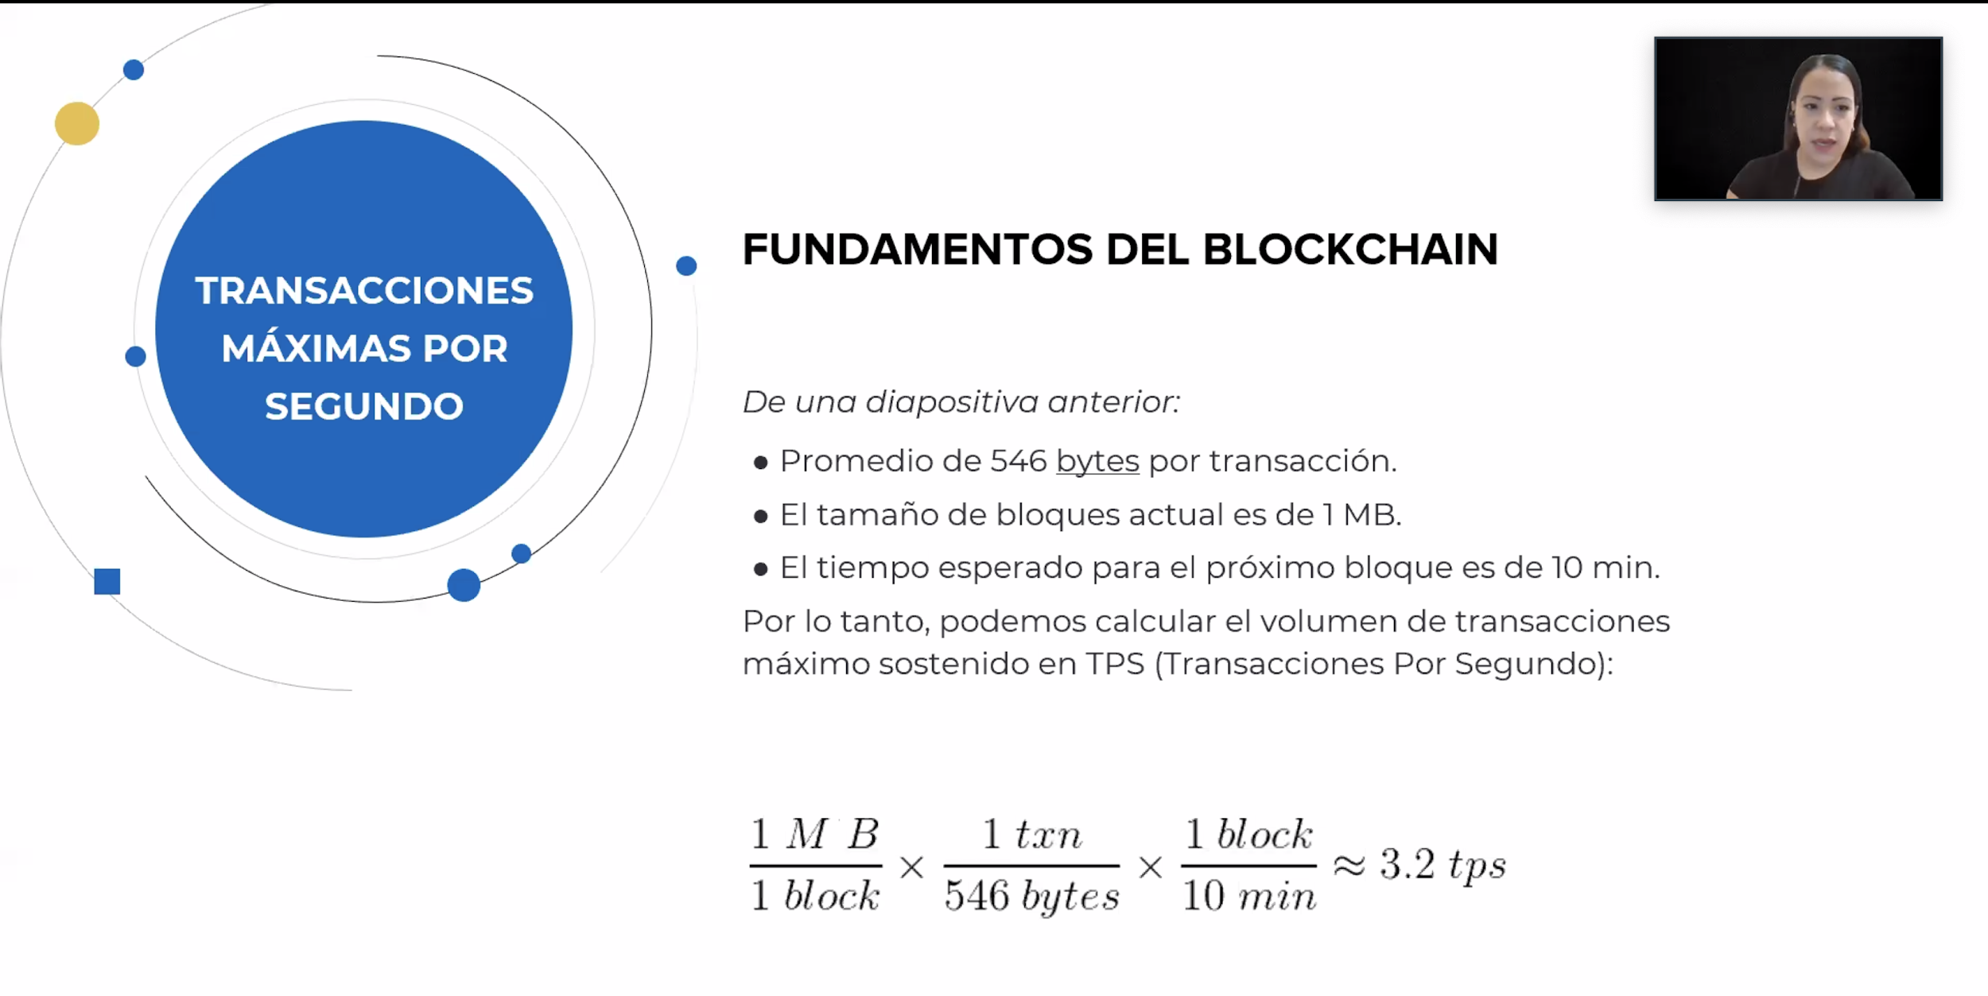

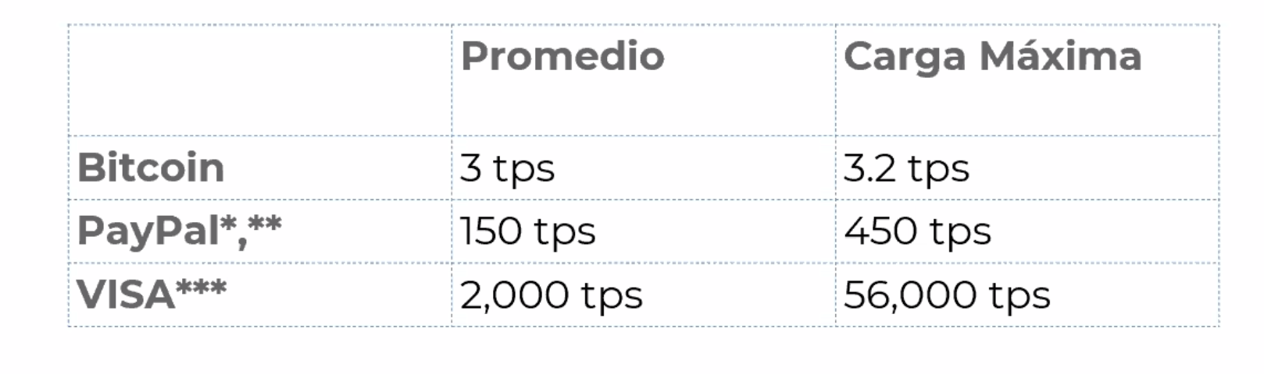

* Bitcoin is not good for paying well because it’s TPS. It is slow.

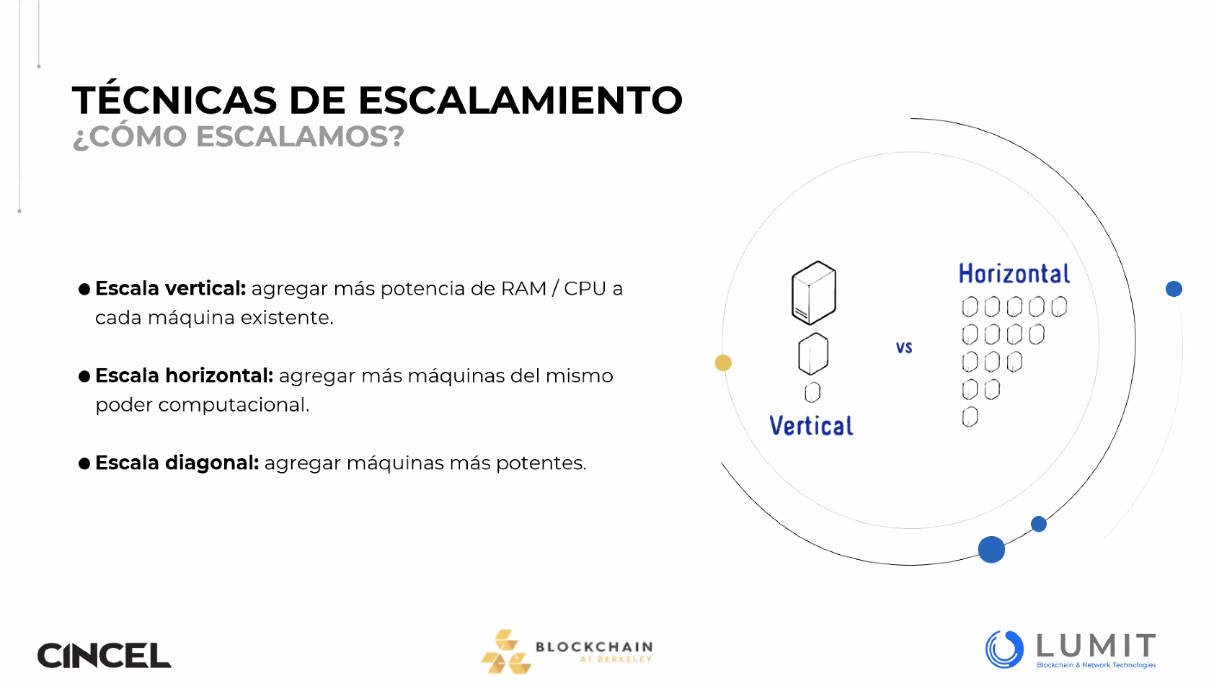

Técnicas de escalamiento:

* Vertical
* Horizontal
* Diagonal

Tiempo de propagación

Tiempo de bloques

Solucion simple

* Porque no aumentar la velocidad de los bloques al disminuir la dificultad del problema de POW?
* Reducir la frecuencia de 10 minutos a 5 minutes
  + Aumento de 1mb a 2mb.
  + Millones de usuarios? Que tanto incentivo
  + ¿Por qué toma tanto tiempo? Porque son determinadas transacciones?
  + No atractivo para micropagos pero podemos encontrar otra funcionalidades

Parte 3.1

Vertical de parámetros cambiantes.

* Hacer crecer el hardware
* Reduce el tiempo de creación de bloques - Añade más recursos a un nodo particular del $sistema (memoria, disco duro, cpu, etc)

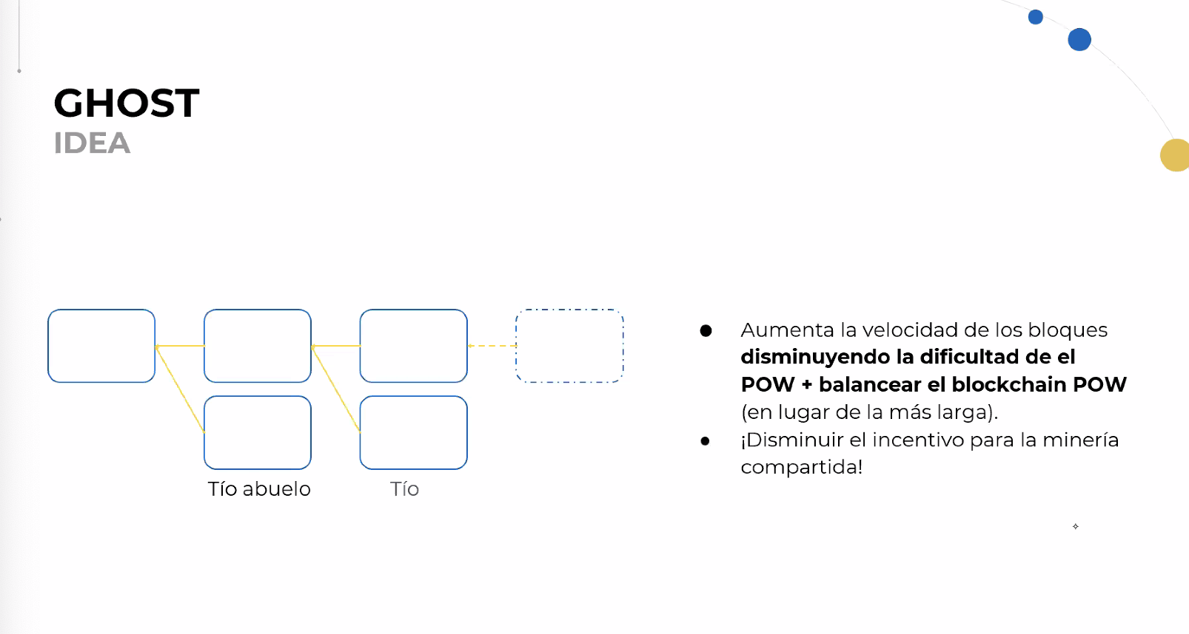

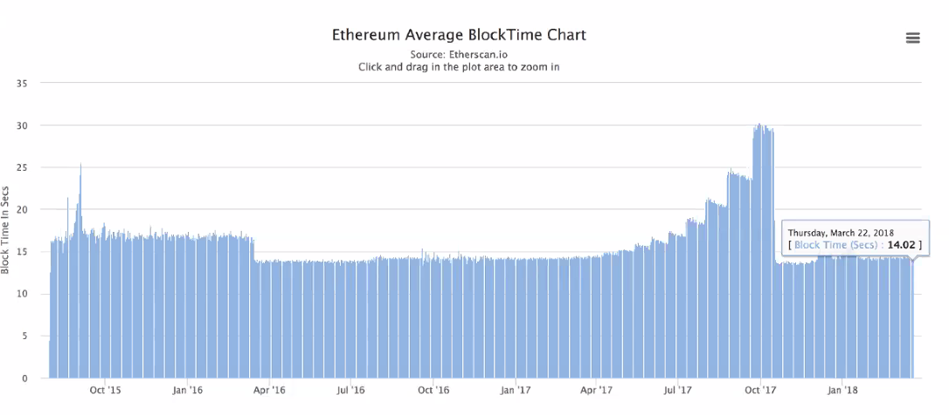

* Alice elige minar en el árbol más pesado
* Los bloques al final se ven como un árbol
* Las bifurcaciones se generan constantemente en la capa principal
* Inclusión de bloques huérfanos (Tíos / uncles)
  + Hasta 7 generaciones

Parte 3.2

Incrementar el tamaño del bloque

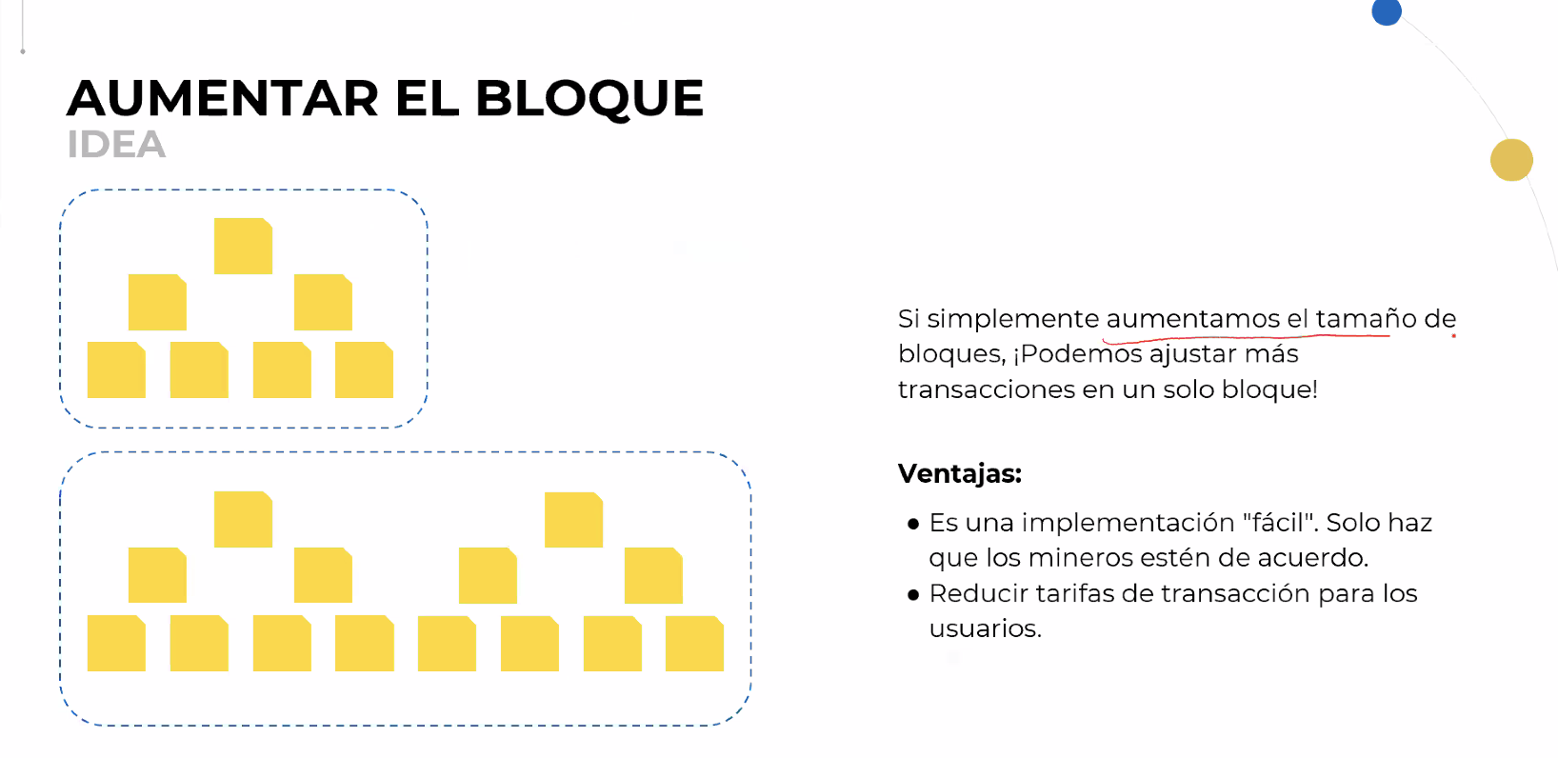

* Podemos ajusta más transacciones en un solo bloque
  + Tienes 1 mb, aumentarlo a 2 mb.
  + Tenemos que pensear cuantos mineros hay actualmente en las redes

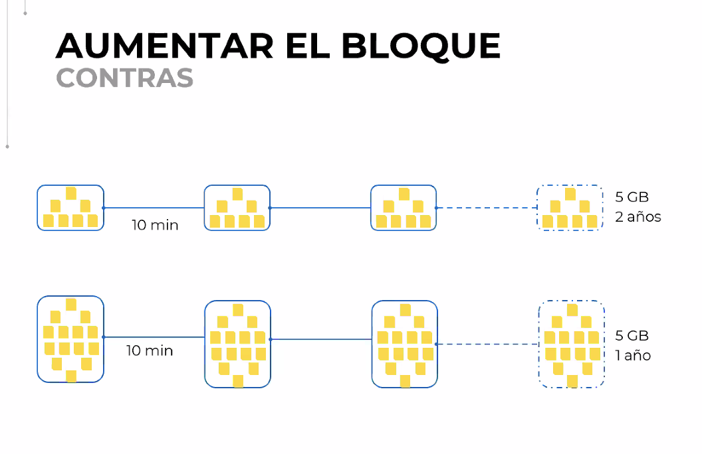

* Hard work
* Se disminuye las tarifas de transacción
* Tamaño aumenta muy rápido
* Tiempos de propagación mas largos
  + Minero auto tiene mejor tiro en el siguiente bloque
* Aumento de capacidad lineal de una vez
* Gran ataque de transacción

Aumentar el bloque

* SEGWIT (Testigo Segregado)
  + Deshacerse de la maleabilidad
  + Datos fuera de las transacciones del blockchain
  + Podría aumentar la capacidad de las transacciones
  + Transacciones de Bitcoin más baratas
* Snarks recursivos
  + Prueba criptográfica para garantizar la mayor privacidad posible
  + Técnica de validación sin tener acceso a la información.

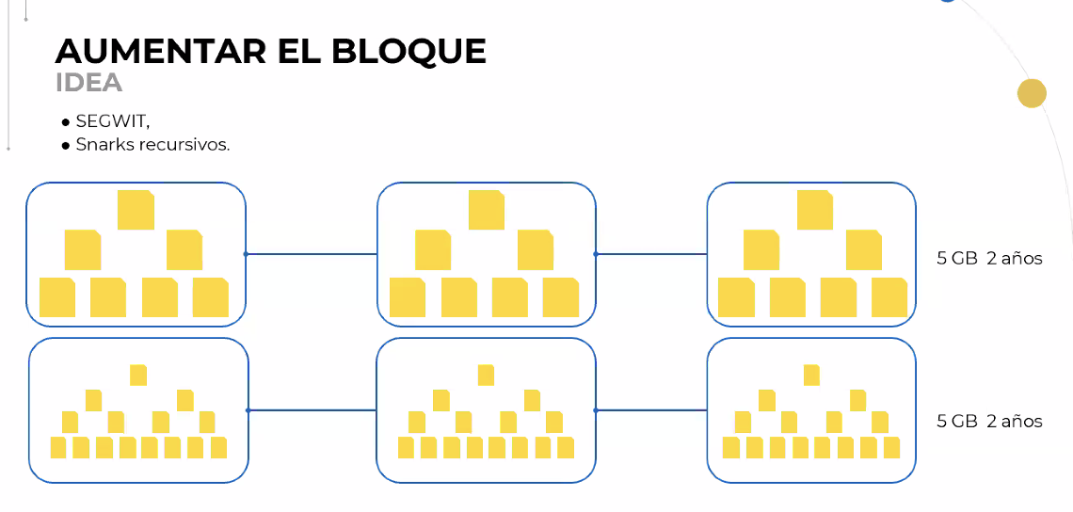

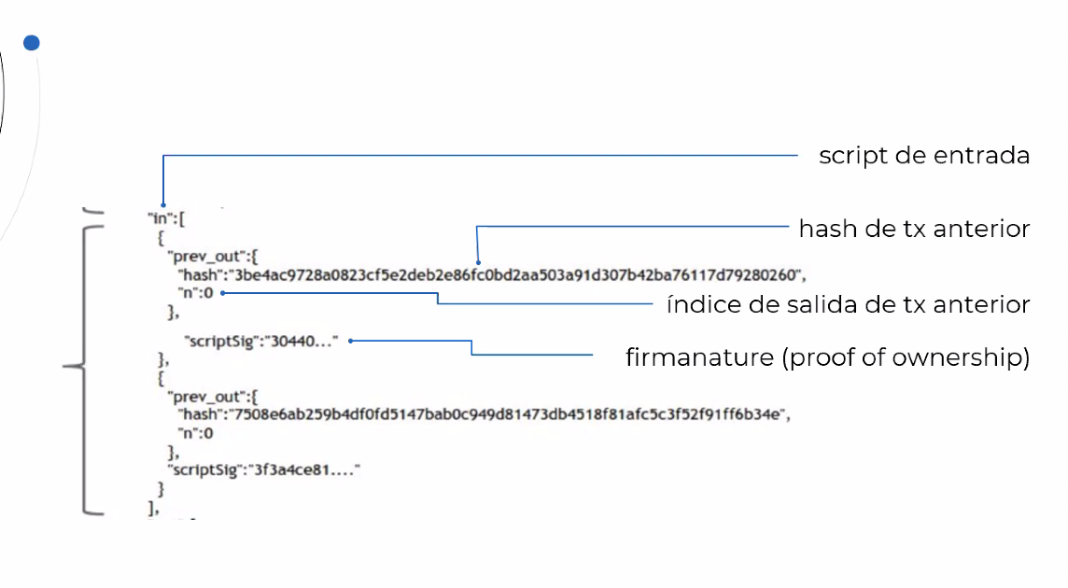

* Arbol de Merkle
  + No es un tema de blockchain
  + Es una estructura de datos (Hash)

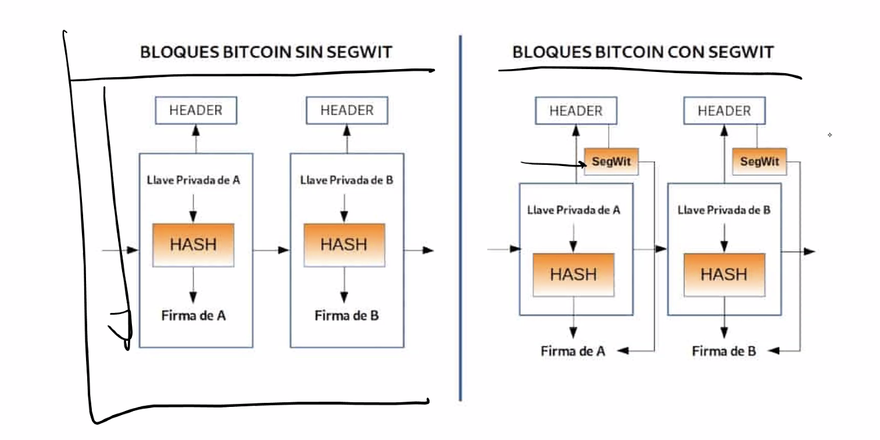

Testigo segregado (Segwit)

* Los datos son eliminados para generar un espacio en el bloque
* La regla es que sea 1 mb
* Relación directamente proporcional entre el peso de transaction y su tamaño

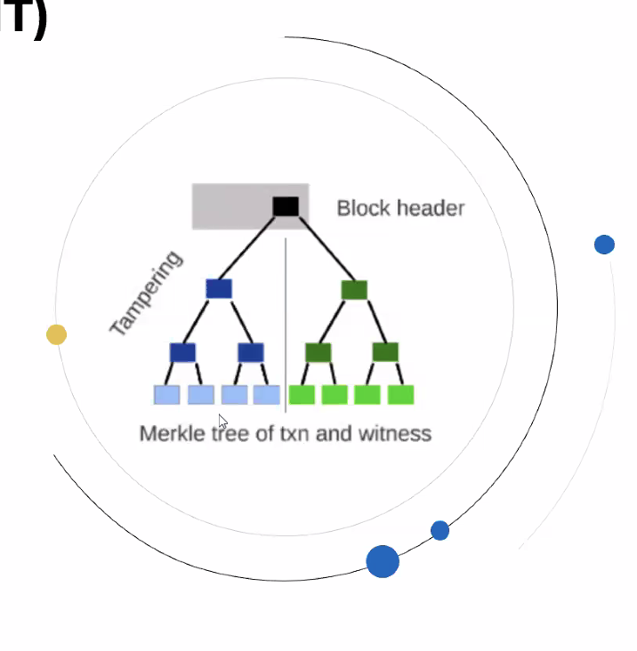

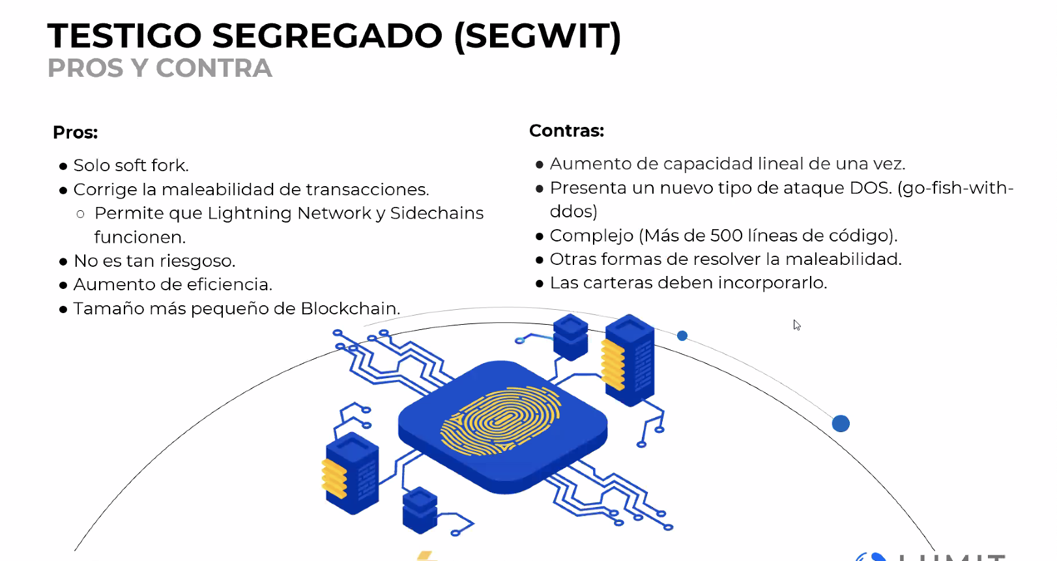

* Con SEGWIT se abre un portal para tener bloques mas grandes
* Llevar de 1m a 4 mb
* Se puede garantizar actualizaciones importantes en el tamaño sin tener que llevar a cabo un HARD FORK
* Puede enviar criptomonedas a otro usuario que tiene un monedero con soporte de nodos legales
* Beneficio en costo de transacción y confirmación de transacciones
* Billetera en SEGWIT

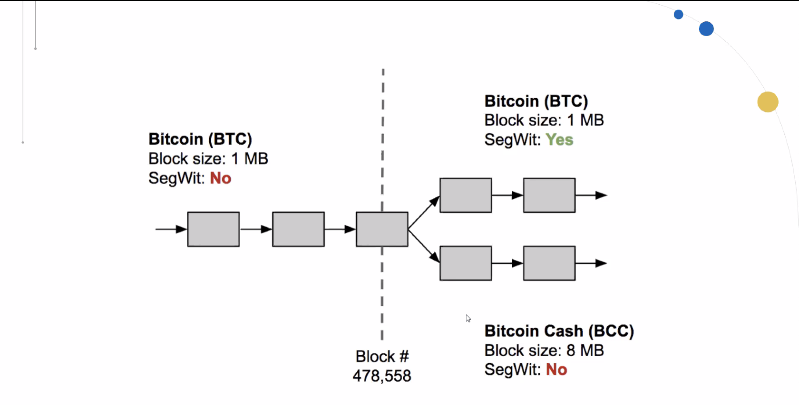

* SEGWIT
  + Reduce el tamaño de transacción de manera externa
* Bitcoin Cash
  + Aumentar el tamaño de bloque

Escalabilidad SNARK Recursiva

SNARK: Zero Knowledge Succinct Non-Interactive Arguments of Knowledge

Prueba de Conocimiento Cero con Argumentos Transparentes Escalables

* Nos permitirá probar la información
* Demuestra que info es correcta
* Nunca se revela (es confidencial)
* Porque se considera el SNARK en blockchain

Escalabilidad SNARK

* Generar una prueba de que se puede enviar una transacción válida de A-B
* Se incluye la prueba en los cambios en el balance
* Cualquier máquina en la red puede verificar en milisegundos
* Protocolos como SNARK garantiza privacidad a todos los participantes en la red de blockchain
* El uso de un SNARK puede reducir cualquier tipo de conexión
* Inconvenientes
  + Consumen demasiado tiempo  
    Requiere configuración de confianza

Escalamiento Vertical

Forma del canal del pago

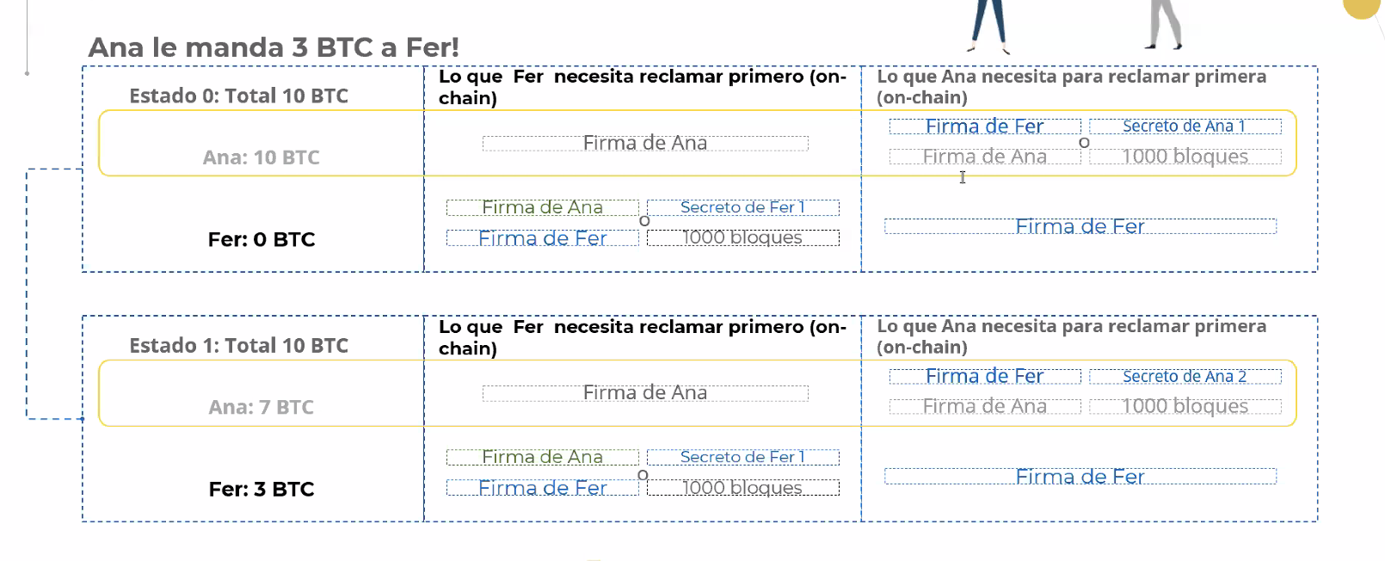

* Todos los participantes tiene acceso a los hashes de manera compartida
* Si uno trata de hacer trampa el otro siempre puede anular y tomar el dinero en el deposito
* Si Ana y Fer siempre cooperan;
  + Nunca tendrán que tocar el blockchain, excepto cuando se crea el canal de pago y se liquida el saldo.
* Solo dos transacciones en el blockchain

Conclusión del canal de pagos

Lighting Network

* Trabajar como segunda capa sobre blockchain
* Ana le envió dinero a Pepe a través de esta red hipotética de canales de pagos

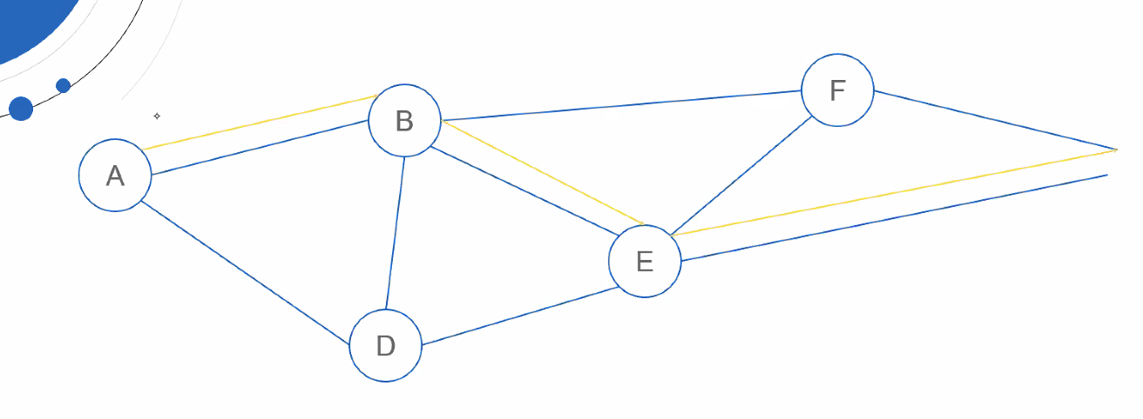

Seguridad

Contruccioin HTLC

Lighting network paper.

* En vez de 3 TPS la red puede admitir 10,0000 tps
* Delegar pagos con contabilida simple en cadca canal de pago
* Es mantenido off-chain el 99% del tiempo

Posibles problemas

* Los nodos deben de mantener cantidades grandes de capital bloqueadas en los canales de pago
* Pagos en una sola dirección
* Fuerte fuerza de centralizacion
* Se reuqiere menos capital con mennos nodos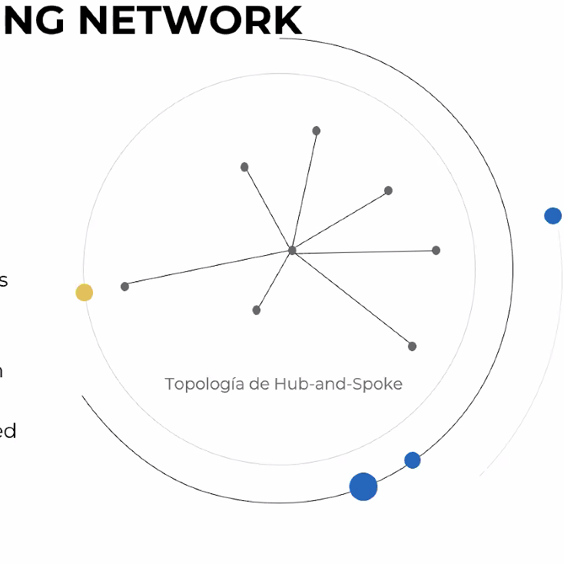

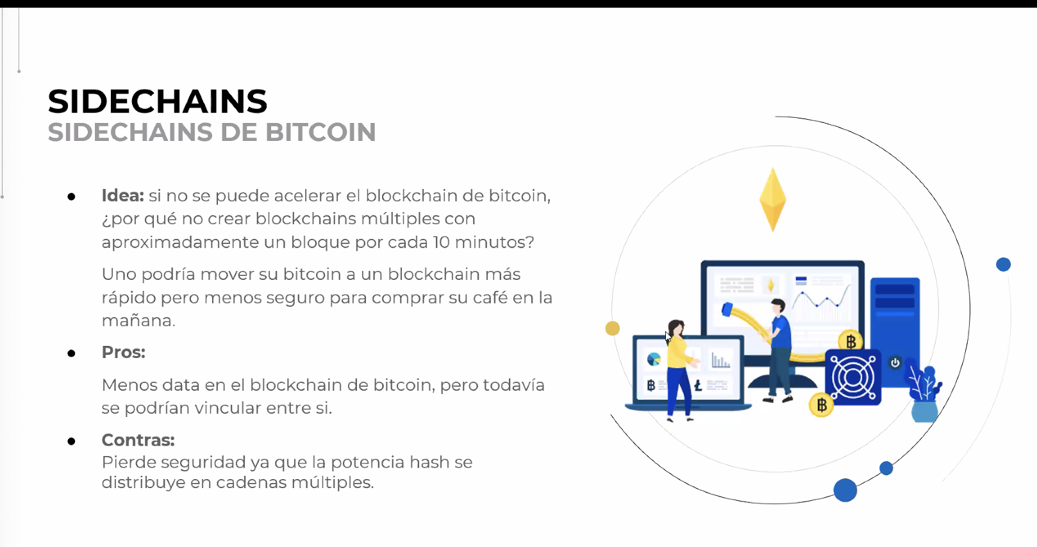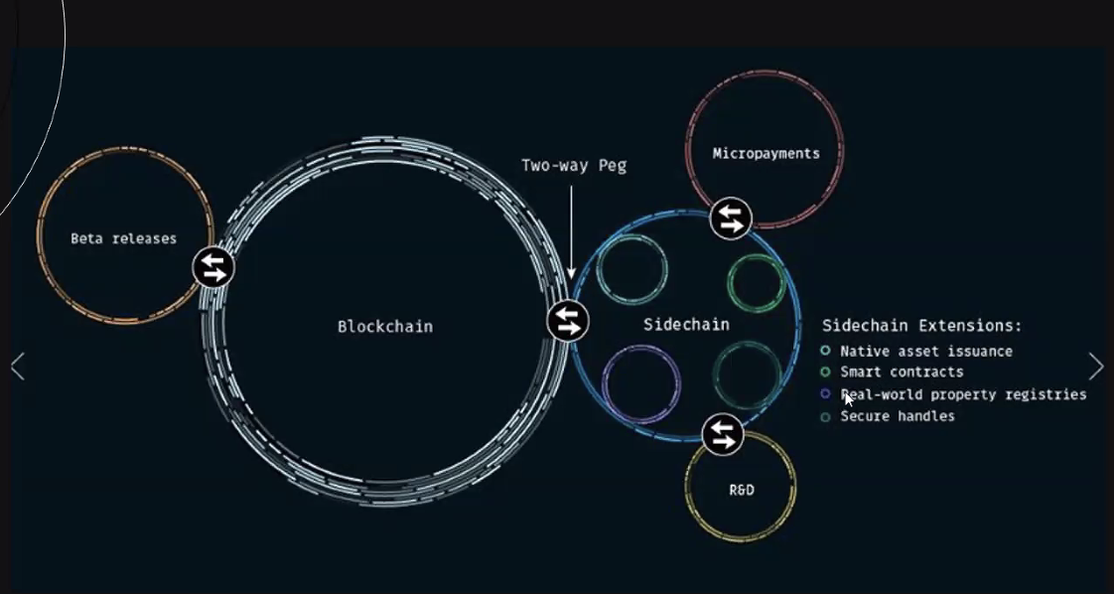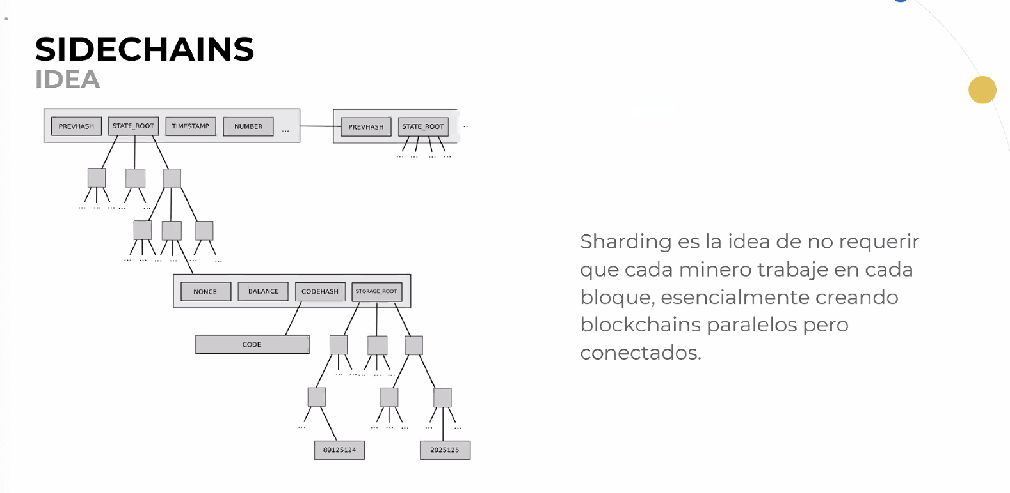

* Liquid Networ

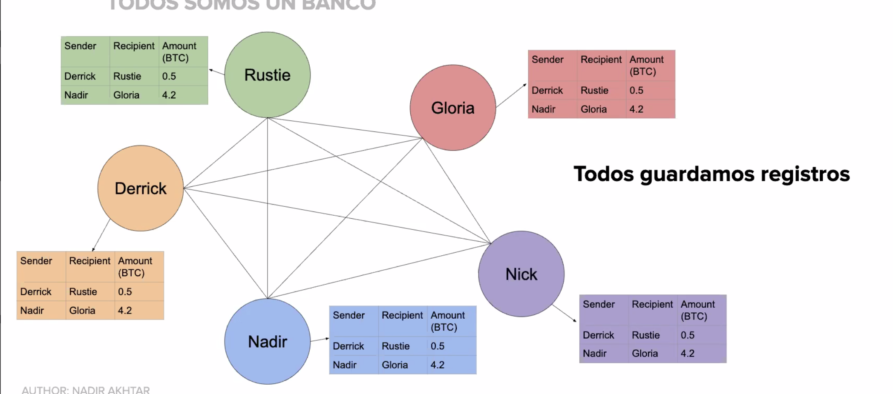

* Info expuesta a todo el mundo
* DLT
* Los blockchain privadas son un poco mas anónimos ya que solo unos poco smiembres tienen acceso a la base de datos,.

Fundamenntos de anonimadad

* Cold wallet
* Buen practica
* No es posible en Ethereum

Fungibilidad; Es la idea que cada unidad de una moneada debe ser igual en valor a cada otr unidad.

Función de Salidas de Transacción

Cambiar direcciones

Identificando Servicios

* Etiquetado por transacción
* Inferir mirando la actividad

Identificacion de Individuos

* Enviando Bitcoin - Revelar direccion
* Descuido
  + Publicar direccion de Bitcoin públicamente en cualquier lugar
* Proveedor de servicio

Analisis “TAINT”

* Manchas en blockchain
* Porcentaje de fondos recibidos por una dirección que se puede remontar a otro dirección
* Revela información útil
  + Ve si diner proviene de una fuente ‘“indeseable”
  + Si no se mezclan los fondos limpios la corrupción permanece intacta sin importar cuántas direcciones inmediatas están involucradas.

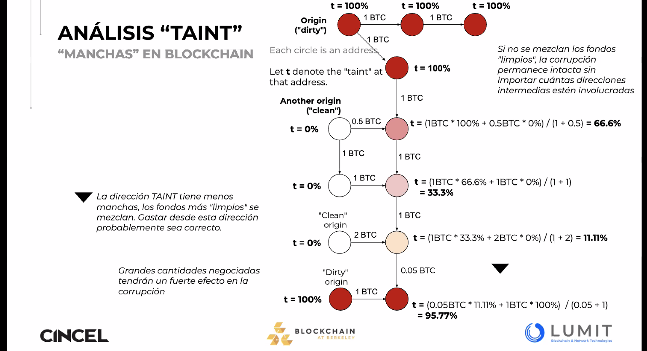

[www.blockchain.info](http://www.blockchain.info) - Herramientas para analisis de TAINT

Anonimidad a través de la mezcla

* Empresas ficticias para lavado de dinero
* Shell companies

Mezcla Lavado de Dinero

Altcoin Exchange Mixing

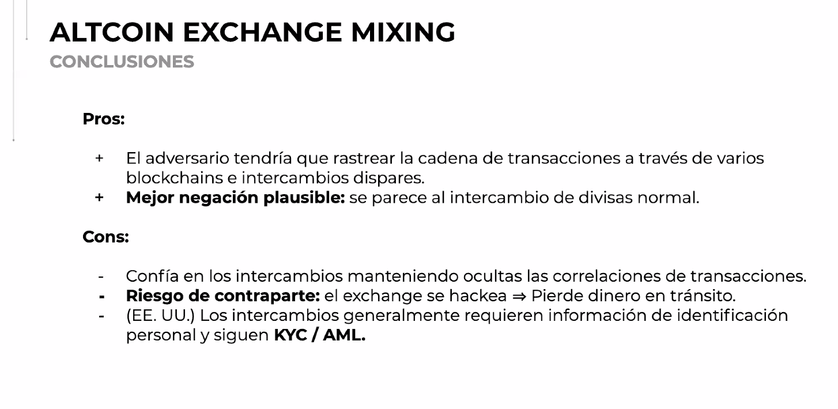

Protocolos de mezcla descentralizada

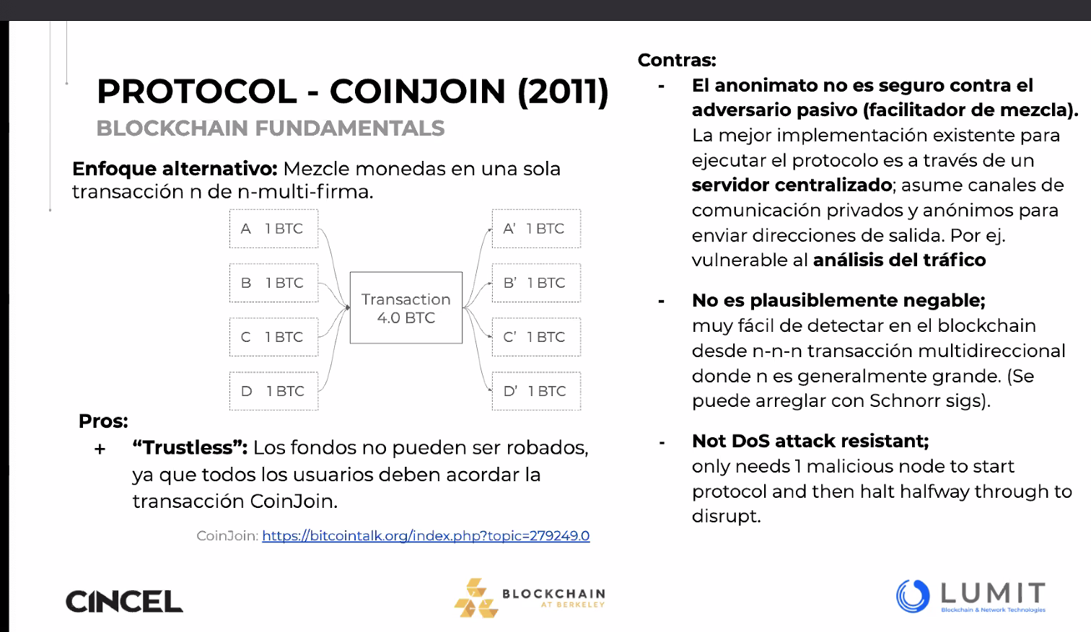

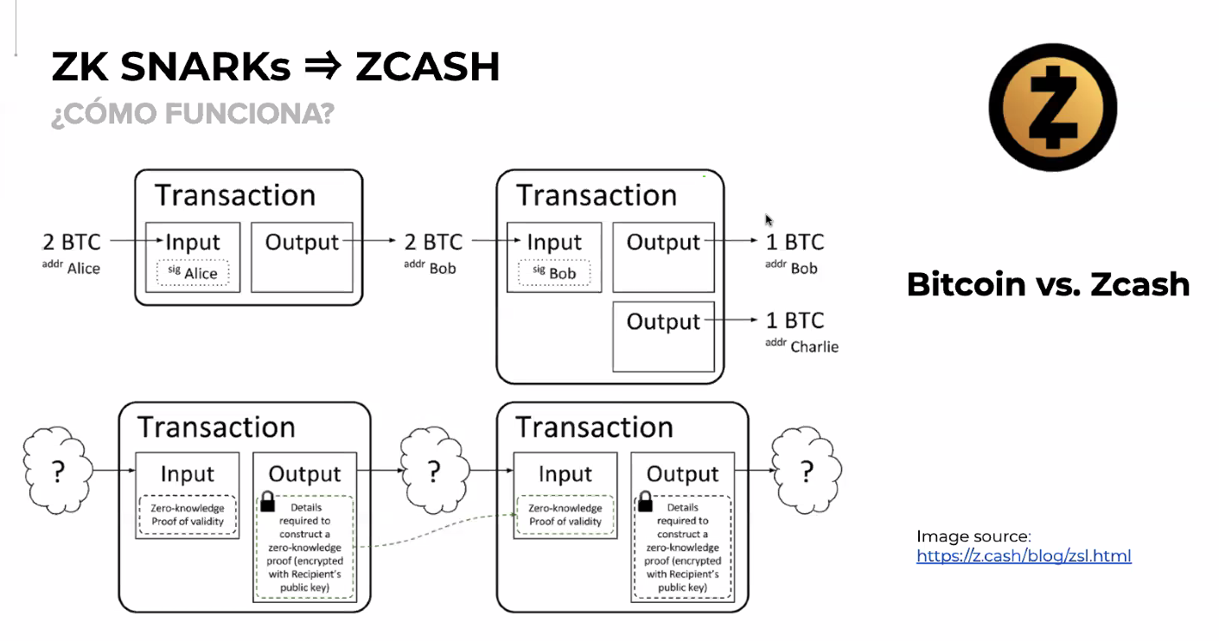

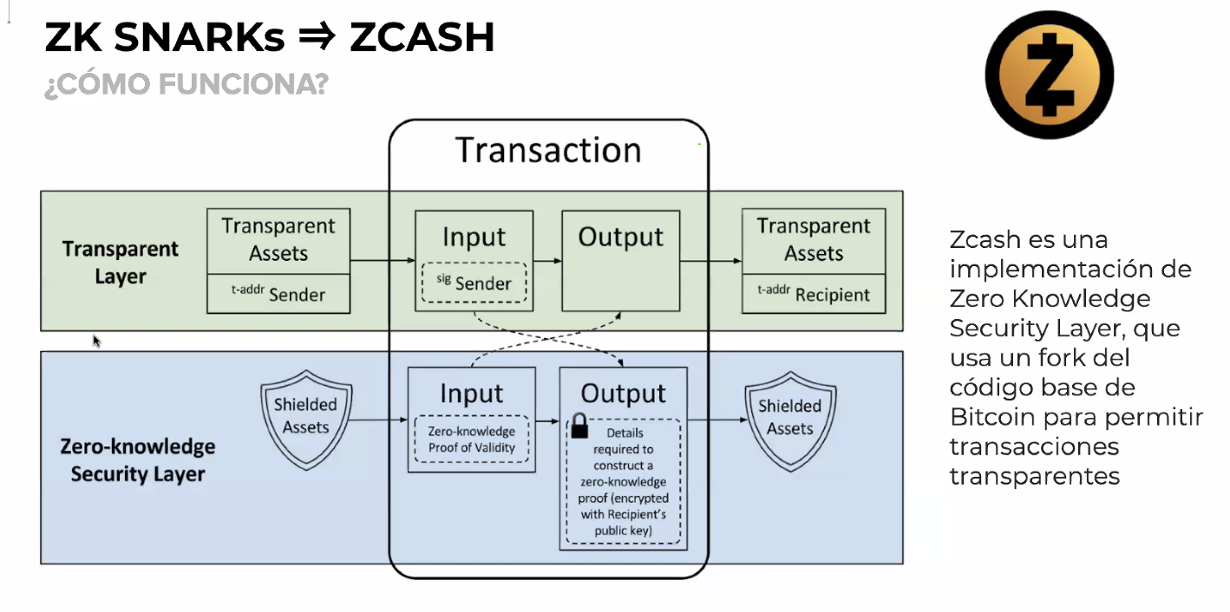

* Zero Knowledge Crew
* Fork codebase Bitcoin

Homomorphic Hiding

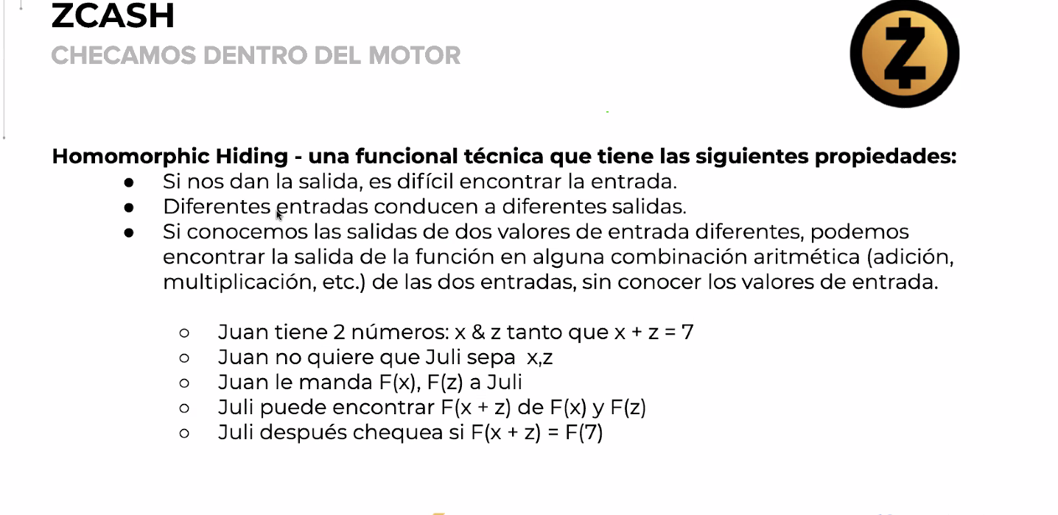

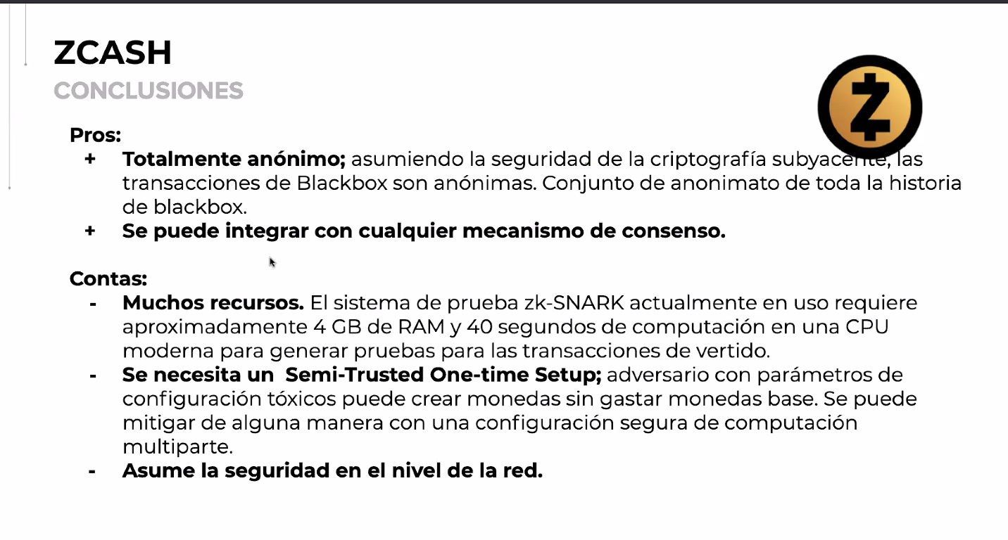

* ZCASH no pertenece solo a un protocolo
* Comprueba computacionalmente que algo se hizo correcto , necesita muchos recursos computacionales
* Transacciones de vertido
* Parámetros de configuración tóxicos
* Semi-Trusted-One-Time-Setup

Temas Avanzados

* Mimblewimble
* Escalable y más anonimato
* Escalabilidad, Seguridad, Anonimato
* MW da anonimato

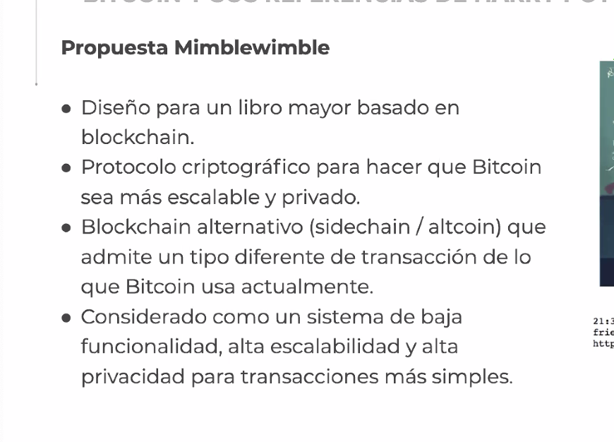

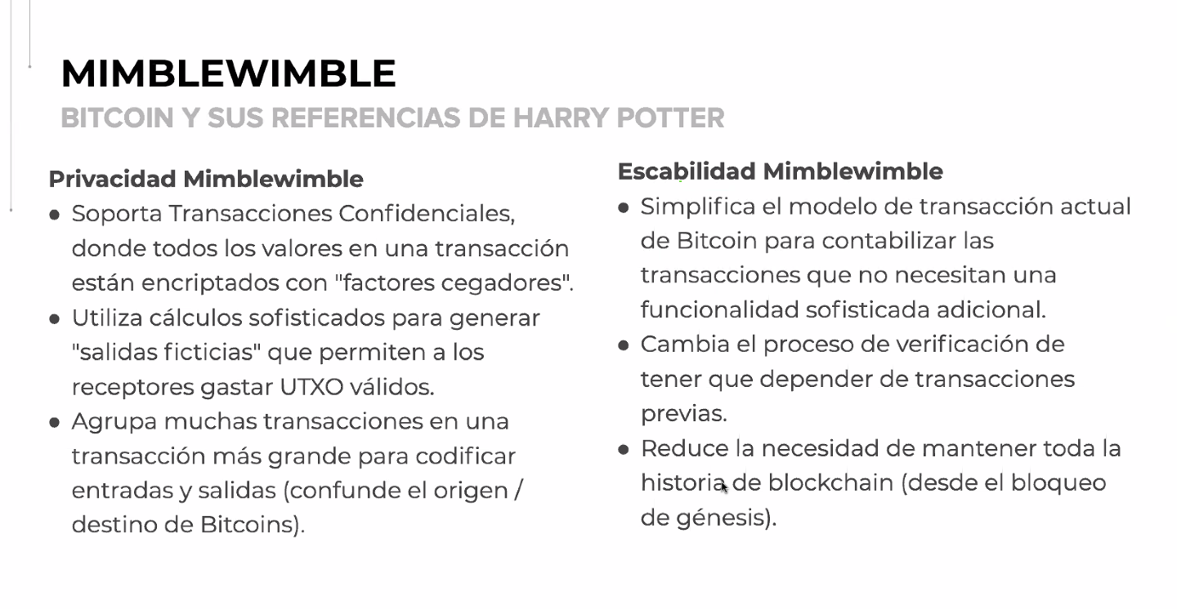

Blockchain at Berkeley

* Open Source research and education
* Hub-Platform as building point
* 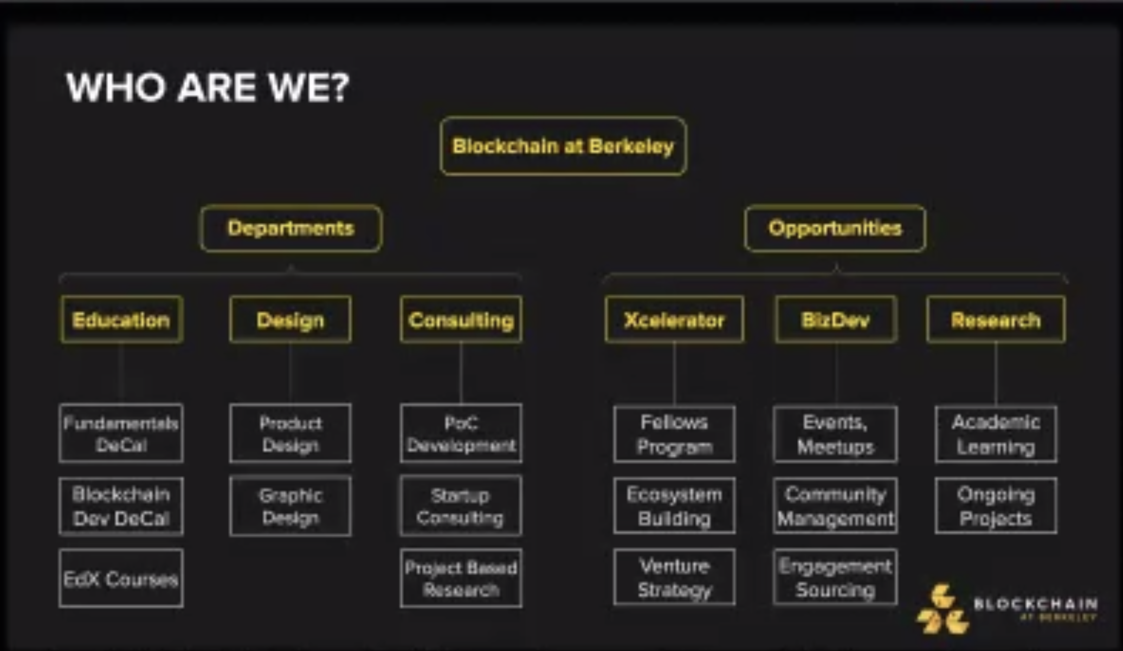

Currency component

* Identity management
* Transactions
* Distributed Ledger
* Trustless Consensus

Consensus Sybil Attack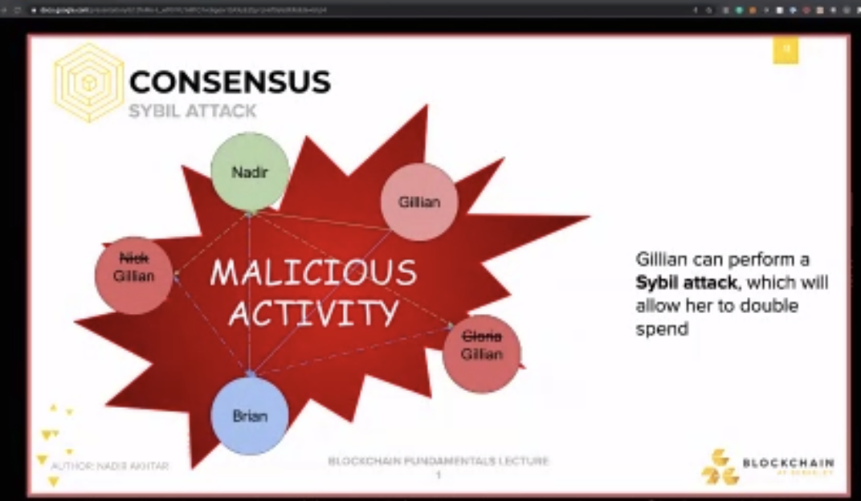

-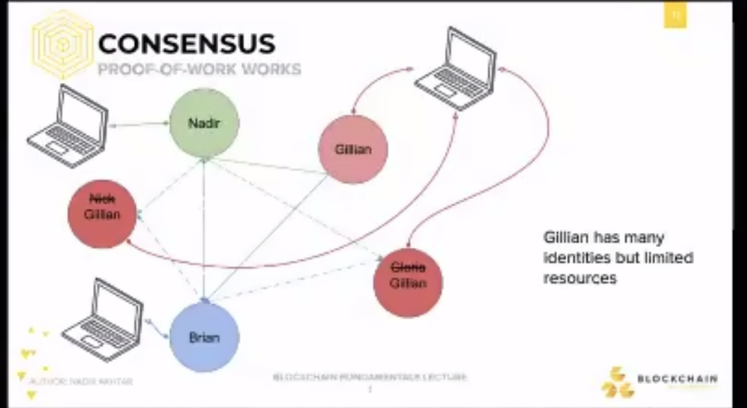

- Proof of work

- Crypto Anarchy - Cyberpunk

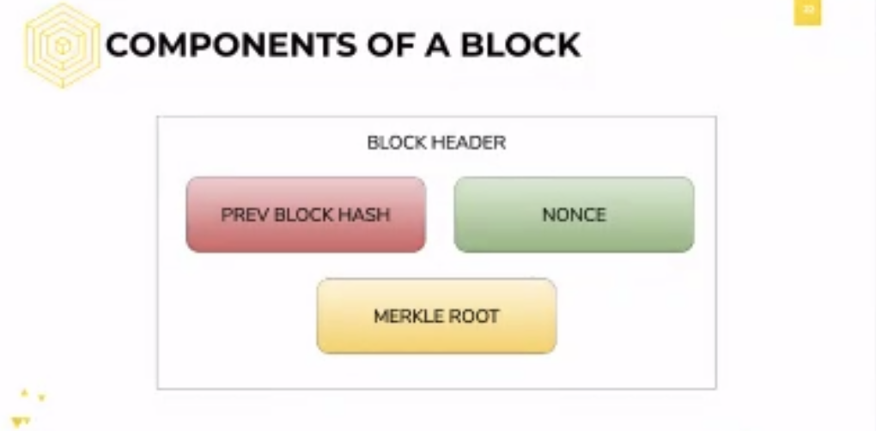

* Keeps track where it cames
* Keeps track of Merkel route

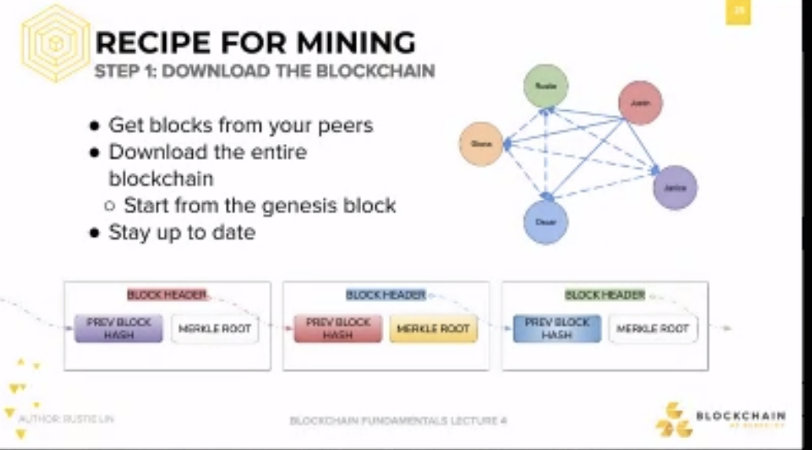

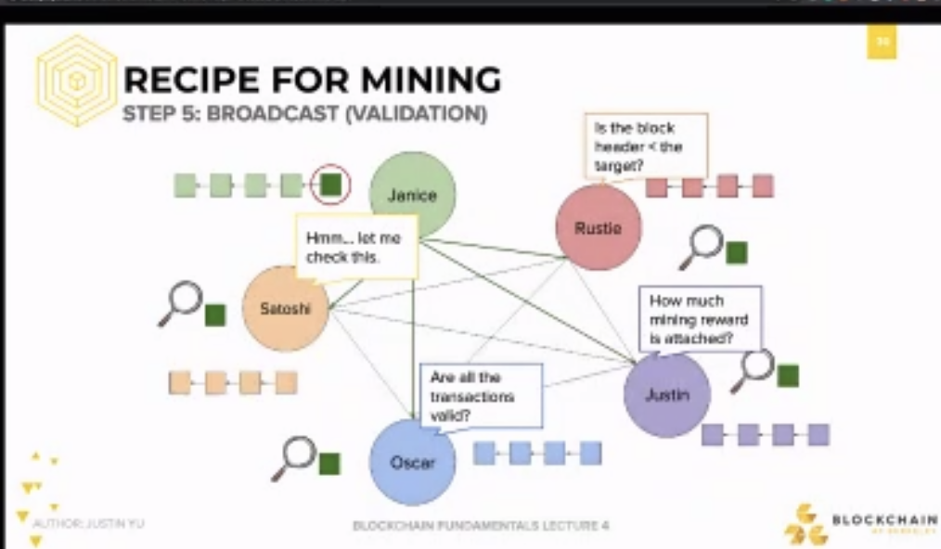

* Distributed globally
* Every block that is mine is absolute
* Validity of transactions

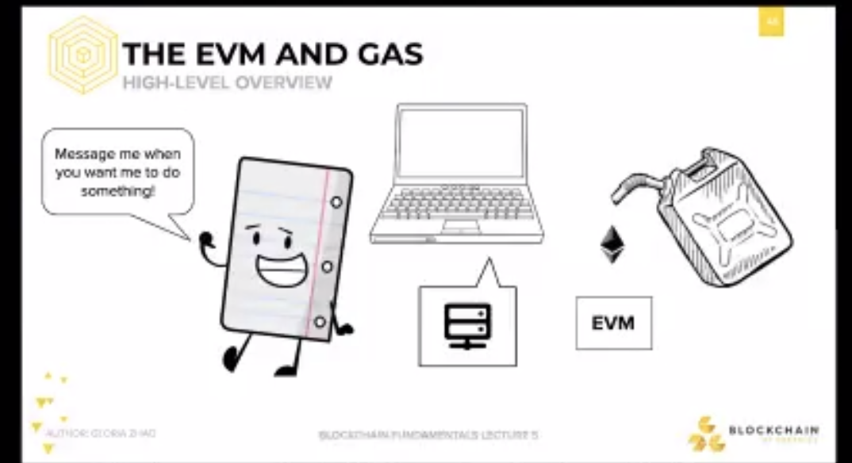

* Decentralized party to send resources.
* Send 10 dlls in Ethereum into the smart contract
* Negotiate
* Send money to the correct party.

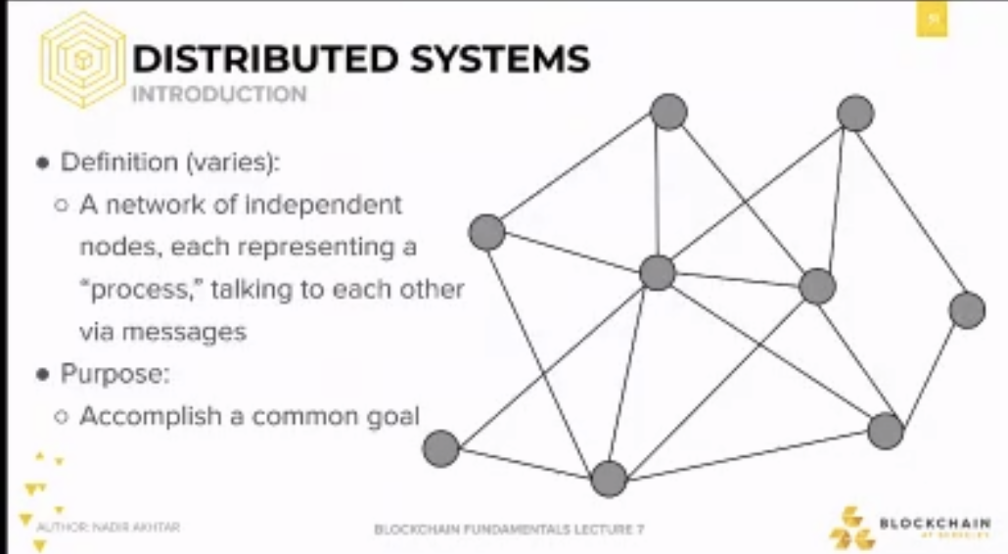

* Proof of Stake

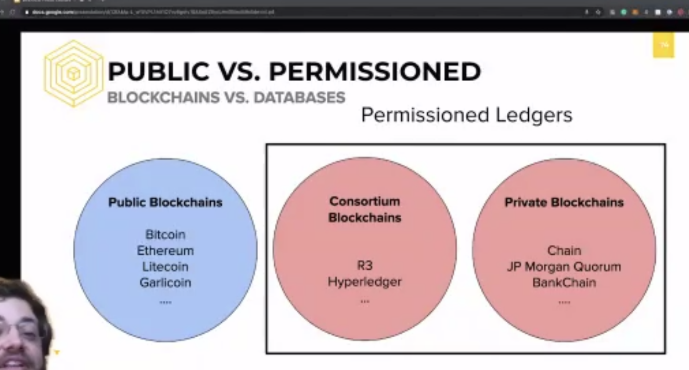

* Hyperledger
* Consensys
* Enterprise Ethereum Alliance
* R3

CBD = Central Bank Digital Currency

Financial Applications and Backends

USE CASES AND APPLICATIONS

* Vehicle and auto part supply chain
* Machine-to-Machine Payments
* Car Sharing

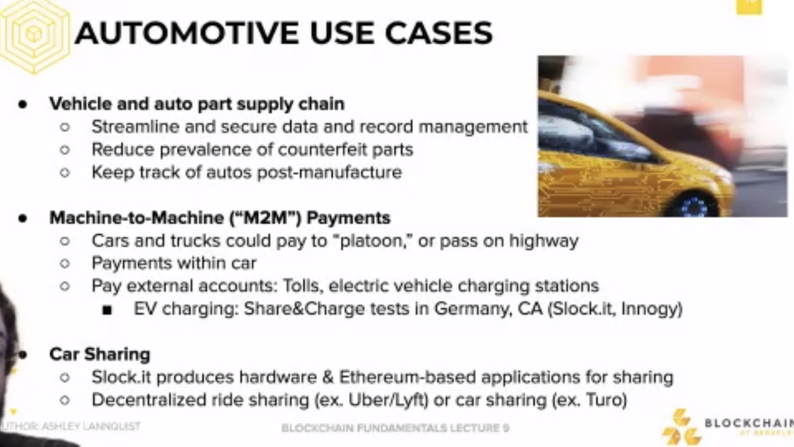

* Auto part fails what its supposed to perform.
* Cars can pay each other to allow track and fast track.
* Car can send payment to commerces
* P2p for drivers without need of Uber or Lyft
  + What else can we by-pass?

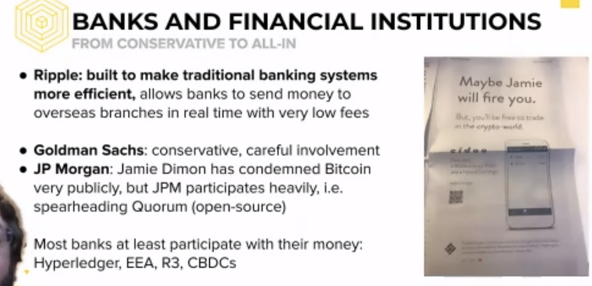

* Moneygram high fees
* Ripple partnered to reduce fees.

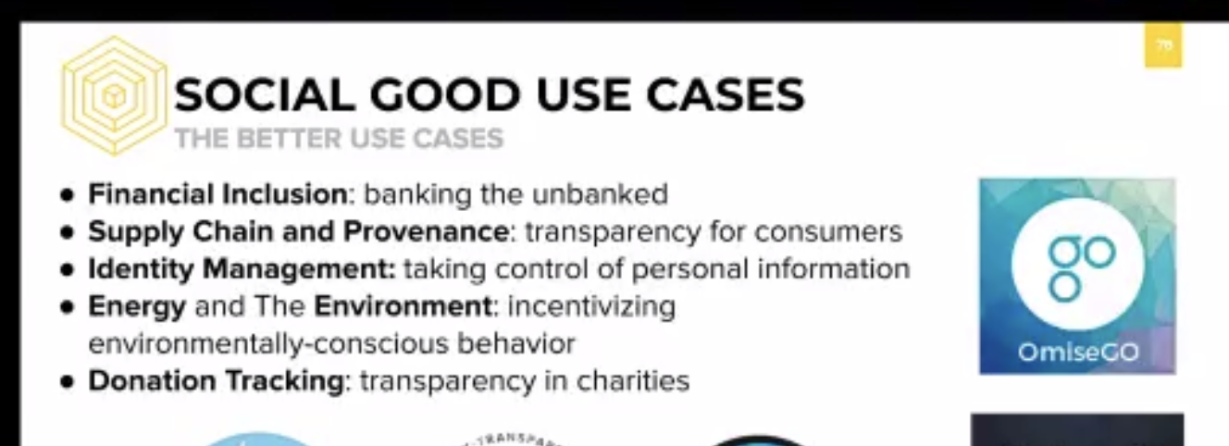

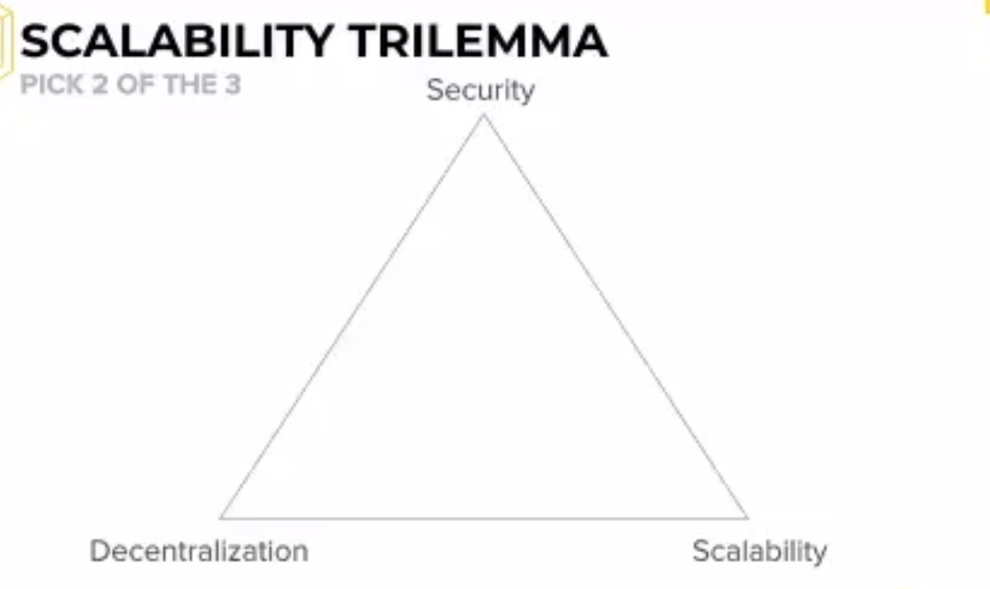

* You can only have 2

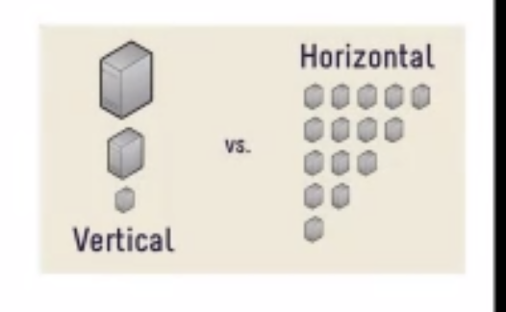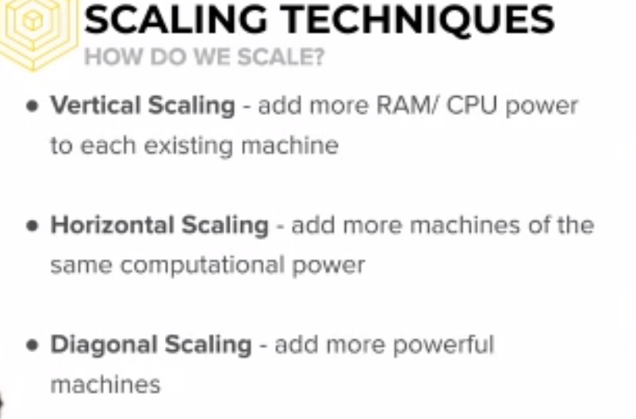

Layer of scaling

* Off-chain scaling
  + Third party services
* On-chain scaling

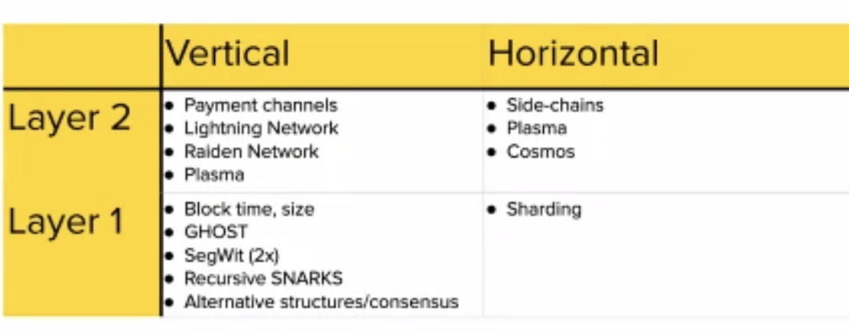

* Payments channels to send money really easy
* There are a lot of transaction happening and can clog networks
* Payment localized channel
* We do constant transactions then at the end of week we confirm all transactions to blockchain

Deanonymization

* Custering: Track and trace where payments are being sent

Decentralized Finance (DeFi)

* Maker
* Uniswap
* AAVE

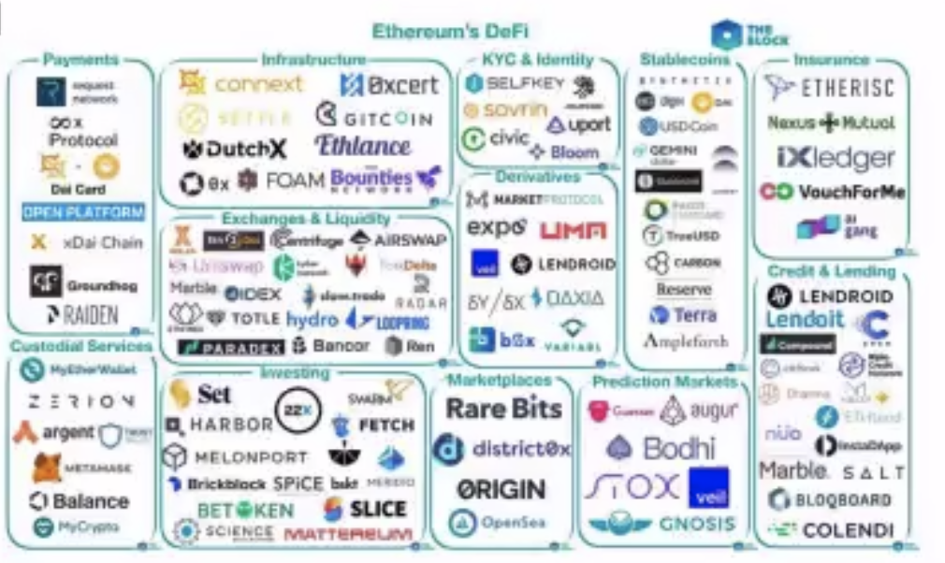

NFT & Gaming

* CryptoKitties
* Flow
* Forte
* Mythical
* Non-fungible assets.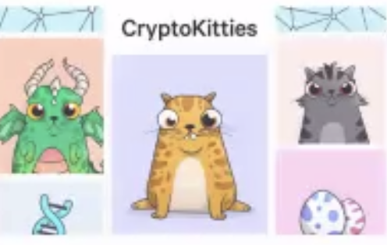
* An entirely blockchain world
* Smart contracts on security
  + If nothing is broken
* Micro donations embedded
  + Where donations are goin
  + Coffe -> Gram ->
  + All accidents are recorded in the blockchain
* Research company
* GIG economy

DAO - Decentralized autonomous organization

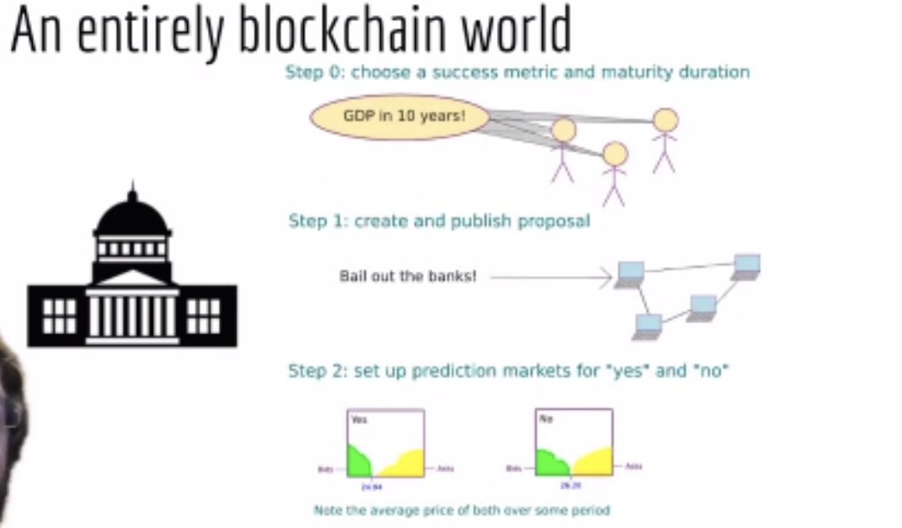

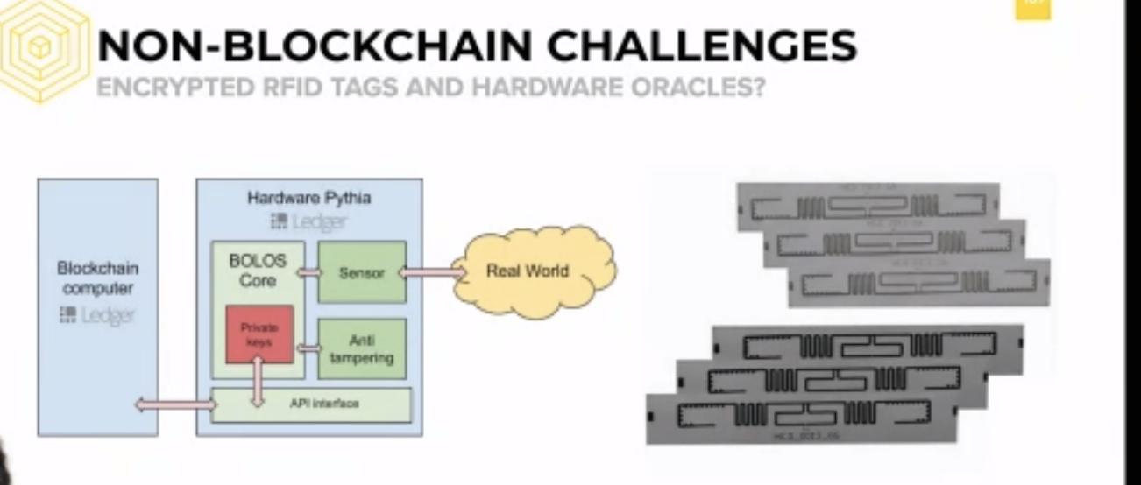

* Ripple pay id - Human readable addresses.
* Take another course
  + Blockchain Fundamentals
  + tinyurl.com/bab-webinar
  + Berkeley Blockchain Xcelerator
  + Blockchain Acceleration Foundation
  + Ben: Blockchain Education Network

CELO

* Seniorage: Estabilizar la moneda 1:1
  + Profit made by a government by issuing currency, especially the difference between the face value of coins and their production costs.
* 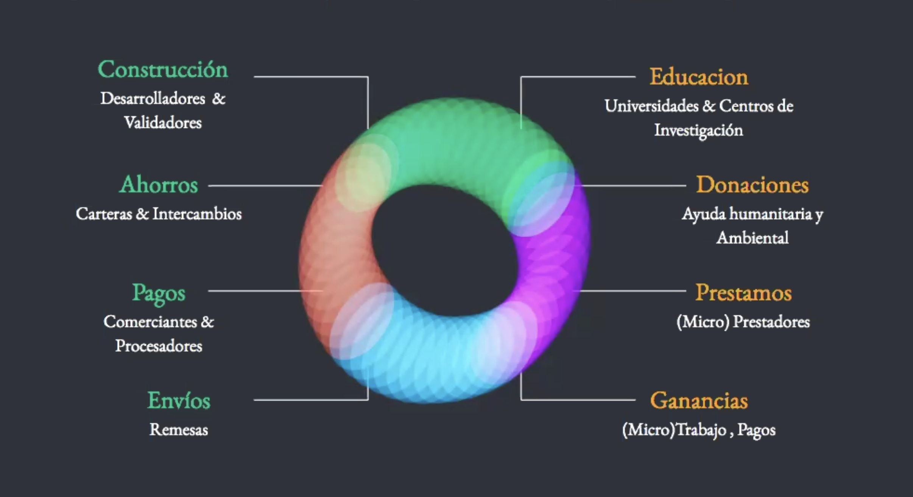
* La gente que está fuera del sistema puede realizarlo sin necesidad de una tarjeta.
* Micro-tareas y dispersa valor vía celular.
* Ahorrar en dólares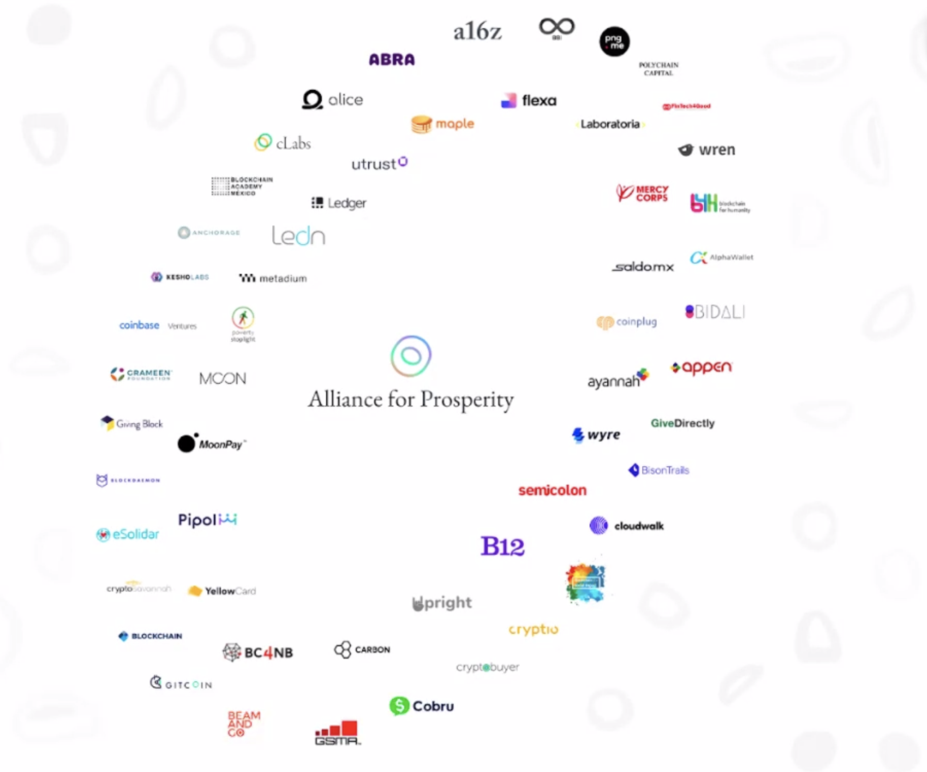

Acciones actuales;

* Celocamp.com
* Programa Embajadores
* Grants
* Abiertos a escuchar sus ideas para contribuir
* Medium.com/celoorg

[angelica.valle@clabs.co](mailto:angelica.valle@clabs.co)

<https://t.me/CeloEspanol>

Stellar en pocas palabras

* Sistema blockchain open source.

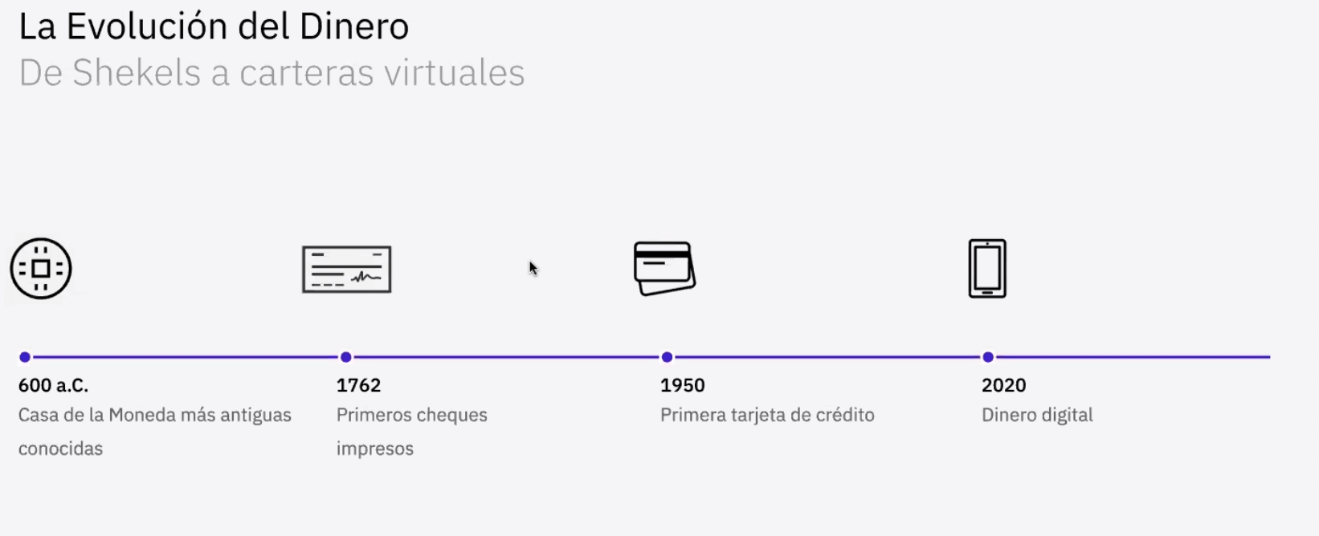

* Un nuevo estandar de pago global
* Tan facil como mandar un email
* Decentralizada
* Costo de comision son bajos

Como actua Stellar>?

* Emitir tokens respaldados por divisas convenciionales (fiat) uno a uno.
* Proporcionar una rampa de entrada / salida fiat
* Entidad ancla “anchor” está obligada a mantener la reserva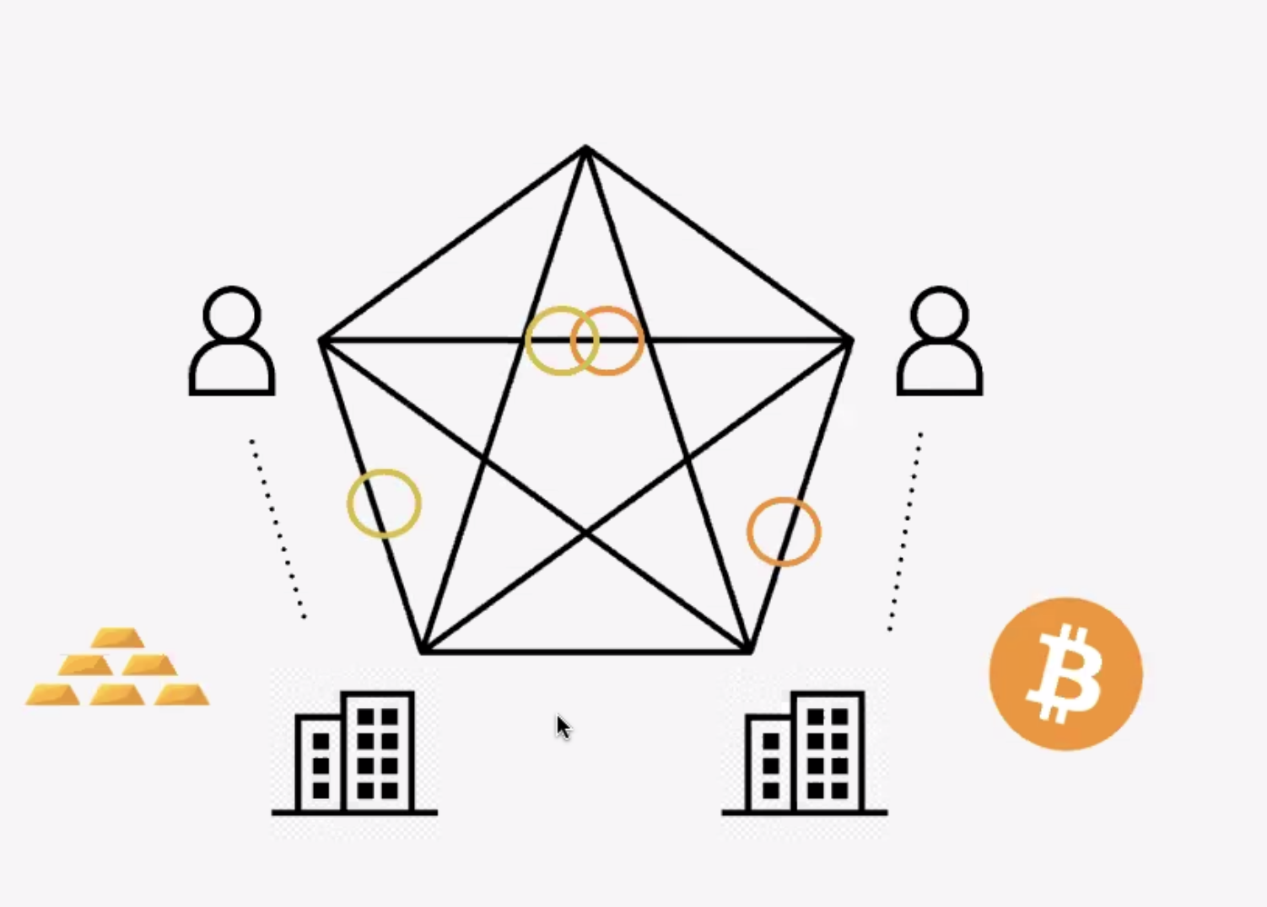
* Generar titulos
* Ordenes de compra yy venta para intercambiar assets